Crooked Creek Cleanup & Crawfish Boil - 2022
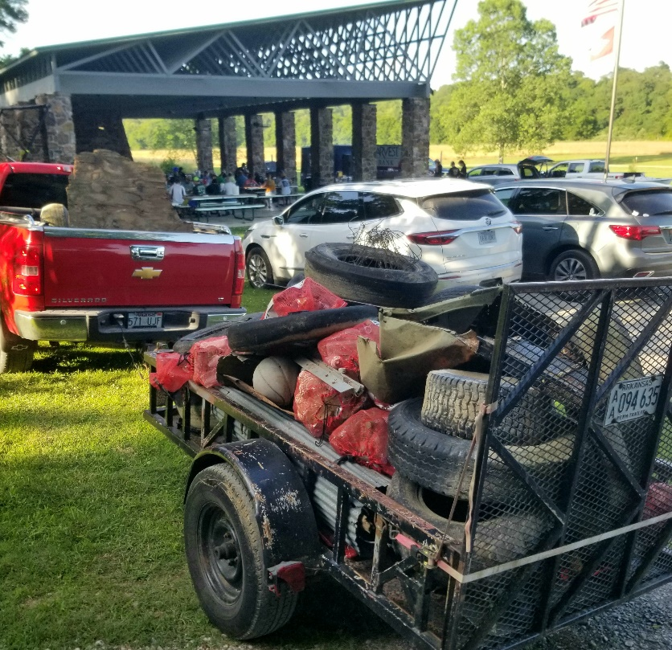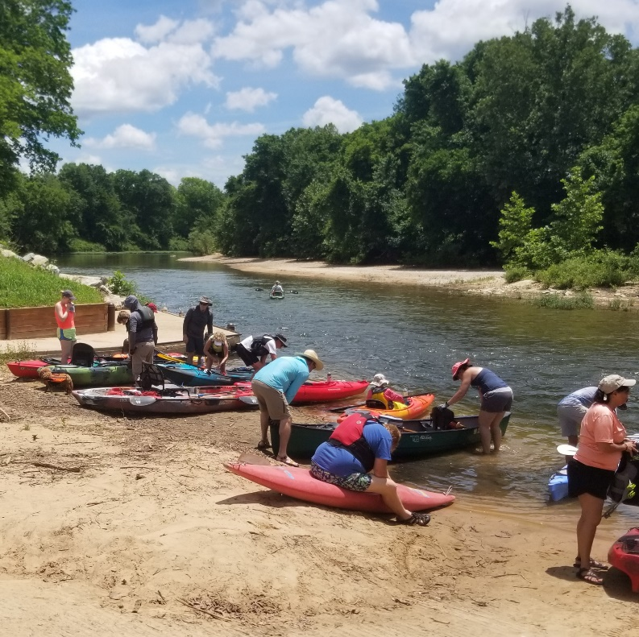

On June 11th, Friends of the North Fork and White Rivers sponsored their annual Crooked Creek Cleanup. This was followed by an all you can eat crawfish boil and grilled burgers at the Fred Berry Conservation Center. Numerous donated items were raffled including a Duane Hada painting and a guided fishing trip on the White River by Cranor’s Guide Service. Everyone enjoyed great music by Bill Coffee under the pavilion. Trash removed from the five-mile section of creek included a record 29 tires.
We believe working together to conserve, restore and enhance our beautiful streams. If anyone is interested in joining or learning more about what we do, check out our website at www.friendsoftherivers.org.

Dodd Creek Bank Erosion Measurements
Dodd Creek is one of three headwater streams originating in Mountain Home. Dodd Creek together with Big Creek and Hicks Creek join south of Mountain Home forming Big Creek which then flows into the White River near Ships Ferry. A section of Dodd Creek flows through the ASU Mountain Home campus and is experiencing significant bank erosion which contributes to nitrogen entering the water. At high levels, nitrogen is a pollutant which negatively impacts water quality and aquatic life.
In 2019 Tim Burnley and Eli Powers with Arkansas Game and Fish Steam Bank Restoration team and aided by members of Friends of the North Fork and White Rivers Stream Team installed 8 rebar pins in the ASUMH section of Dodd Creek where significant erosion, as evidenced by deep cut-banks, is occurring. The pins were identified with GPS coordinates and stream bed and bank measurements recorded. The purpose of setting the pins was to establish baseline bank measurements for comparison with future measurements.
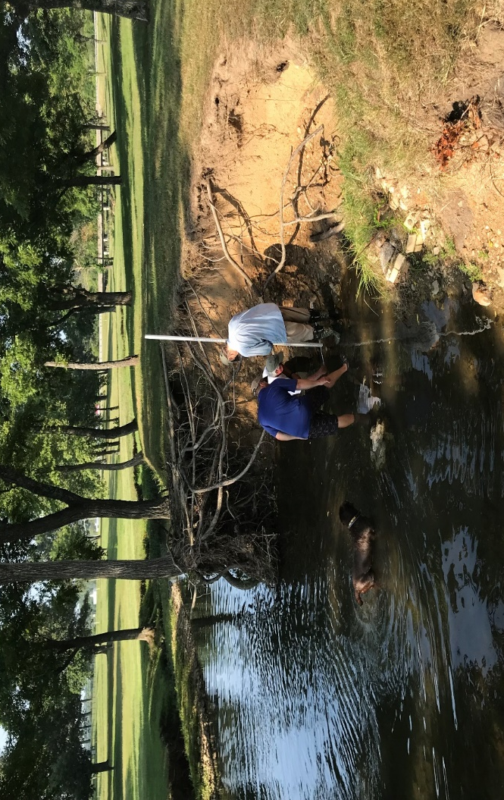
In May 2020 and July 2021 measurements were made to determine bank erosion the amounts of sediment entering the water.
Recent measurements indicate continued bank erosion which will require stabilization.

Reporting Waterway Debris
Taking care of Arkansas’ navigable waterways is very important
Here is a tool to report debris including trees, limbs, old boat docks that are thrown or abandoned in the water especially if they become a navigation hazard.
https://waterways.cosl.org/
Mountain Home High School 2022 Scholarship Recipients
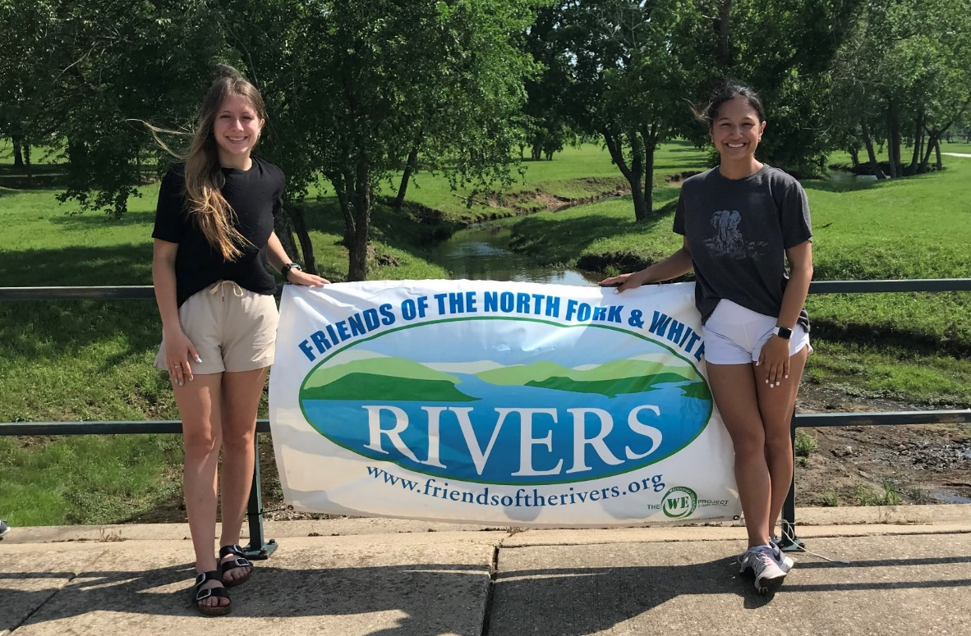
Rylee Patterson & Joia Traver

Corrective Action Plan Update – City of Yellville Sanitary Sewer System
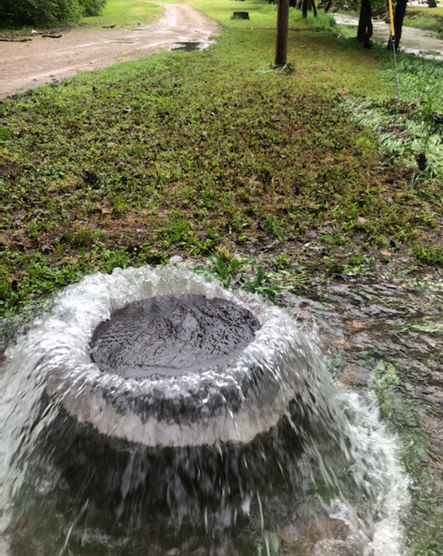
The latest quarterly report of the Corrective Action Plan (CAP) reveals that the project is still on schedule. The purpose of the CAP was to create a plan for making improvements to stop the sanitary sewer overflows. The CAP was requested by the Arkansas Department of Environmental Quality in its Consent Administrative Order in October, 2021. Read about the Order in our article link
Yellville / Flippin Sewer Violations Follow Up | Friends of the North Fork & White Rivers (friendsoftherivers.org)
Since the last quarterly report, plans for the scope of the project were approved by the Arkansas Health Department and the project was advertised for bids on September 15, 2022. No further milestones were set for the next quarter. The Construction Contract will be awarded within 45 days after the bids have been opened if adequate funding is secured.
Federal grant funding in the amount of $4,000,000 is being pursued through the Natural Resource Division of the Arkansas Department of Agriculture and funds made available by the Federal Infrastructure Bill.
Earth 911 Recycling Search
Find where to take your recyclables in your area of the watershed.
https://earth911.com/

This is an excellent opportunity for landowners to learn how water quality and forest management are related.

Arkansas Department of Corrections Ordered to Eliminate Pollution of Moccasin Creek
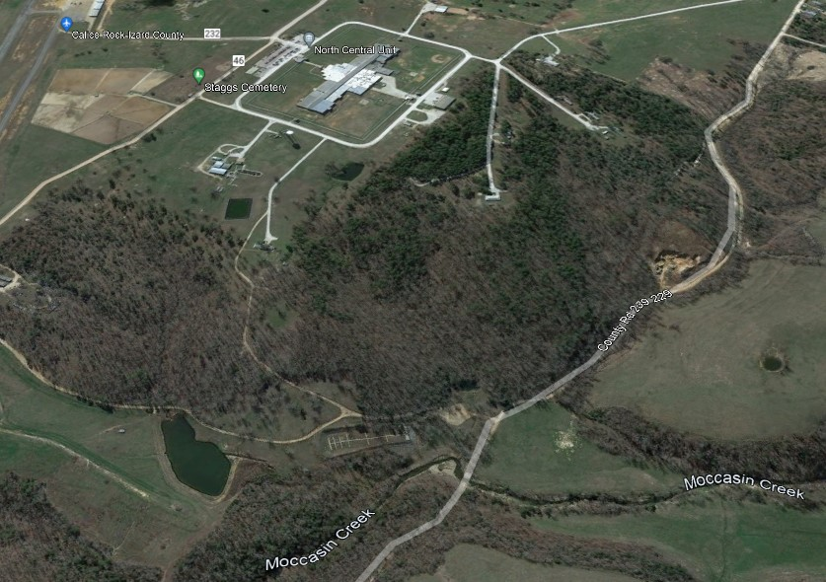
According to the Arkansas Department of Environmental Quality (DEQ), the wastewater treatment facility of the Arkansas Department of Corrections (ADC) has polluted Moccasin Creek, a tributary of the White River, on numerous occasions over the past decade. These violations of the facility’s Clean Water Act discharge permit stretch back to at least 2012.
The DEQ, on December 13, 2021, published a review of the certified Discharge Monitoring Reports submitted by ADC in accordance with its Clean Water Act permit. Violations included fecal coliform bacteria, nitrate, suspended solids, oil & grease. The full list can be found on our website.
The review also revealed that ADC reported flows greater than the facility’s permitted design flow every month out of the 36-month review period.
The ADC must submit to DEQ for approval a comprehensive Sanitary Sewer Flow Monitoring and Infiltration and Inflow ((I&I) Study within 90 days. The Study, required to be developed by an Arkansas Professional Engineer includes, at a minimum:
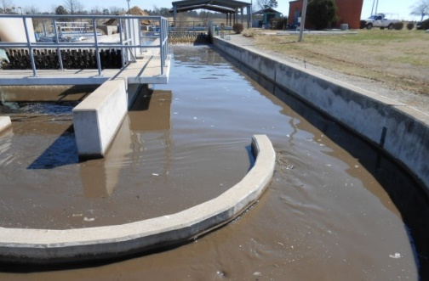
- A baseline for sanitary sewer flows
- Rainfall monitoring
- Estimate of sewer capacity
- Identification of sources and amount of I&I (leaks in and out of the collection system)
- Corrective Action Plan and Milestone Schedule for reducing I&I with a date of final compliance
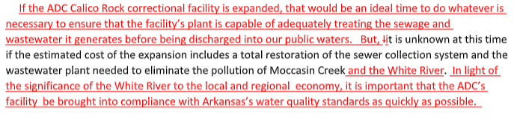
A civil penalty of $6,400 was assessed, and additional daily fines will be assessed beyond the compliance date if compliance is not achieved.
The full article can be found here.

Friends of the North Fork and White Rivers
FNFWR advocates for clean and healthy water in the Middle White River watershed, from Batesville to Bull Shoals. It is a 20-year-old, volunteer driven, 501(c)(3) nonprofit organization.

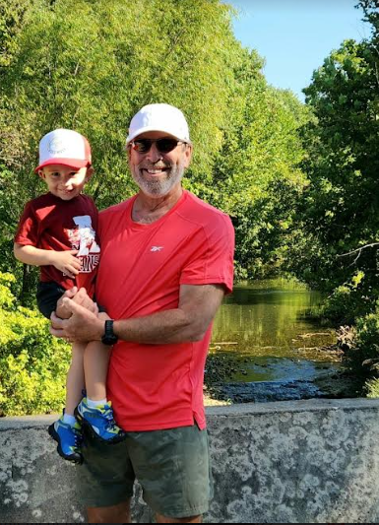
We have entered the Ozarks' best time of the year. If your family is like mine, yours is fishing, biking, hiking, hunting or just driving backroads. The middle White River watershed includes Mountain Home at the upper end and Batesville at the lower end, with many lively small towns in between that are rich in history and culture.
A national forest, a national river and several wilderness areas are found here, along with a section of the Ozark Highland Trail. Mountain Home is cradled by two large lakes with nearby tailwaters that provide top quality trout fishing. Three of the EPA's highest rated streams make their way through the bluffs here. The White River exits the Ozarks and joins the delta near Batesville between the Springfield Plateau and the Boston Mountains.
Abundant water is found in this middle White watershed. But we know that it is water quality that really sustains the wildlife, the economic vitality and the attractiveness of the watershed. Consider joining Friends of the North Fork and White Rivers in our mission to protect this precious water quality.

Please support Friends of the North Fork and White Rivers’ efforts to protect our streams, lakes and rivers by:
- Joining or renewing your 2021 membership
- Making a financial contribution
- Volunteering for Stream Team and stream clean up events
- Contacting your elected officials and agencies when necessary

Thank you again for your support.
Sam Cooke
President
870-307-8922
Sdcooke22@gmail.com

