Safety:
- Ensure that the UTV is safely parked on level ground with the ignition off.
- Wear all appropriate PPE for the following procedures.

Note:
- Leave all hardware loose until the entire assembly is in its final position.

Assembly Components:
Ensure that you have all of these components before beginning the installation.

1 x Lexan Back Panel
1 x Hardware Kit
6 x Roll Cage Clamps

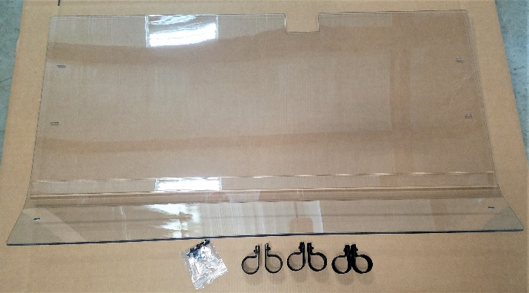
Figure 1: Kit Contents

Installation:

- Position the Lexan back panel on the rear of the roll cage. Ensure that the notch at the bottom is placed over the seatbelt spool housing. If the machine has a roof, make sure that the roof overlaps the back panel.

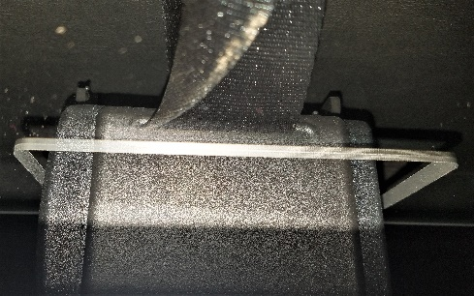
Figure 2: Seatbelt Spool Notch

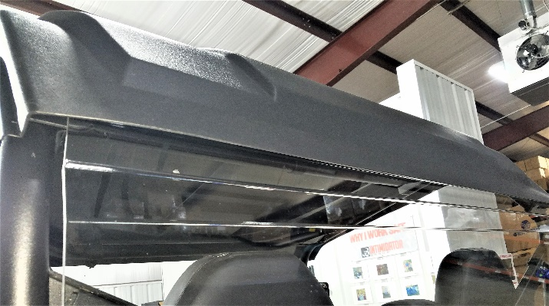
Figure 3: Roof Overlapping Back Panel
- Place the roll cage clamps onto the roll cage and align them with the mounting holes on the back panel. Secure the panel to the clamps using the included machine screws and flat washers.
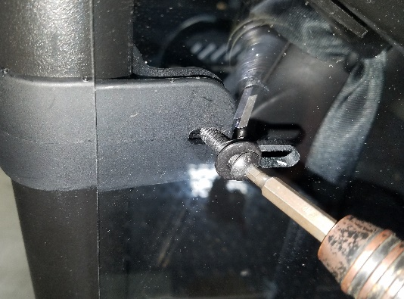
Figure 4: Securing Clamps
Note: The back panel fit has a very tight tolerance. If the mounting holes do not line up exactly, rotate the clamp so that the machine screw will enter the back panel at an angle in order to reach the clamp. Figure 4 demonstrates this technique.
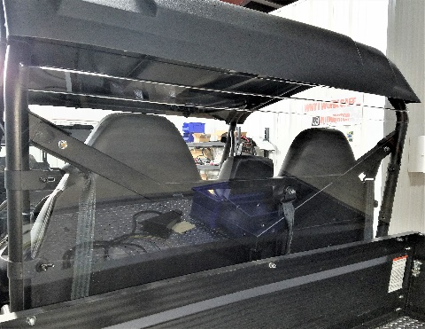
Figure 5: Install Complete

