It is recommended that bolts remain “hand tight” until all bolts are installed.
CONTENTS:
- Front Roof Panel
- Rear Roof Panel
- 13- 1 ¾” Plastic Tube Clamp with “U” nut included
- Bolt Kit
- 1- strip of adhesive rubber bumpers
NOTE: The bumpers are provided to reduce vibration noise. There is one recommended area to place them, others are provided to use at installers discretion.

STEP 1  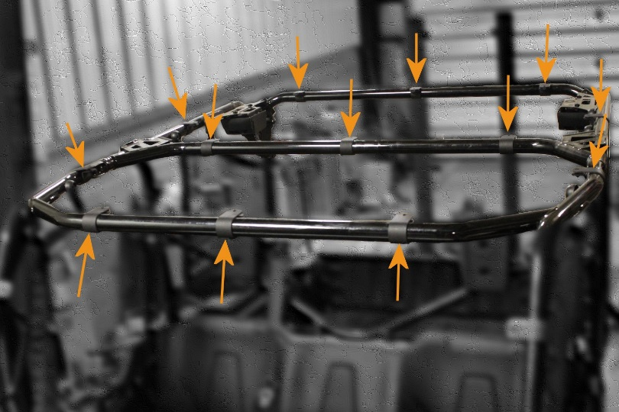 | - Place the provided 1 ¾” plastic clamps (“U” nuts included) in the approximate locations indicated here.
STEP 2  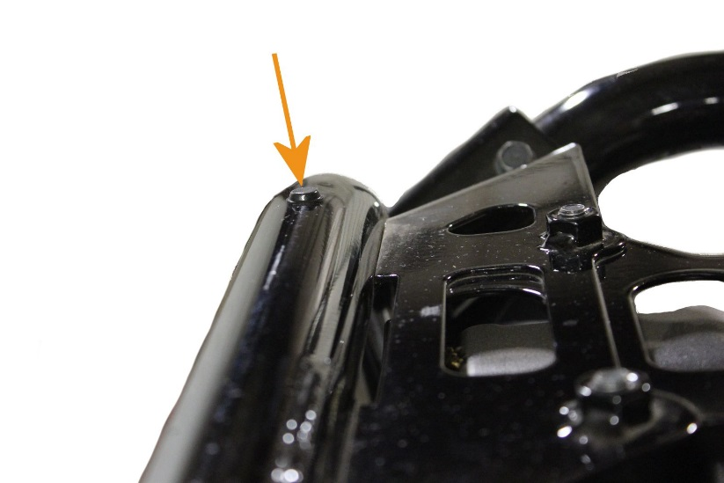 | - Place at least one adhesive rubber bumper in the rear corners as shown here.  Note: this view is of the passenger side rear of the machine.

STEP 3  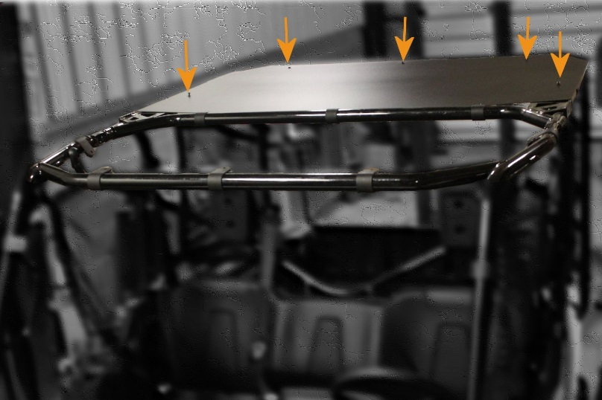 | - Set the rear roof panel in place.  - Align the precut holes in the roof with the corresponding holes in the plastic clamps.  - Start (don’t tighten yet) the provided ¼ -20 x 1” button head bolts with flat washer.
STEP 4  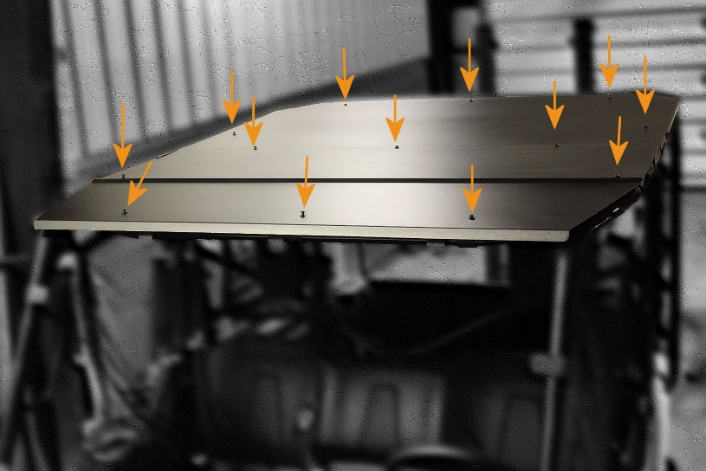 | - Set the front roof panel in place.  - Align the precut holes in the roof with the corresponding holes in the plastic clamps. The front panel will overlap the rear panel and the center holes will align.  - Insert the ¼ -20 x 1” button head bolts with flat washer.  - Once all the bolts are started, make any final adjustments for square and tighten the bolts.

