Safety:
- Ensure that the UTV is safely parked on level ground with the ignition off.
- Wear all appropriate PPE for the following procedures.

Note:
- Leave all hardware loose until the entire assembly is in its final position.
- Have the gas tank empty when installing this accessory.

Assembly Components:
Ensure that you have all of these components before beginning the installation.

Needed
- Rubber mallet
- Drill
- Impact driver or rachet
- 9/32 Drill bit
- 23/64 Drill bit
- Socket adapter
- Deep 1/2-inch socket (optional)
- ½ inch socket
- ½ inch wrench
- Center Punch
- Paint marker
Provided
- 4 x ½ inch nuts (613-3049-00)
- 4 x ½ inch bolts 2 ¼’’ long (618-2034-00)
- 4 x ½ inch self-tappers (618-2021-00)
- 8 x washers (619-8044-00)
- 6 x end caps (614-3410-00)

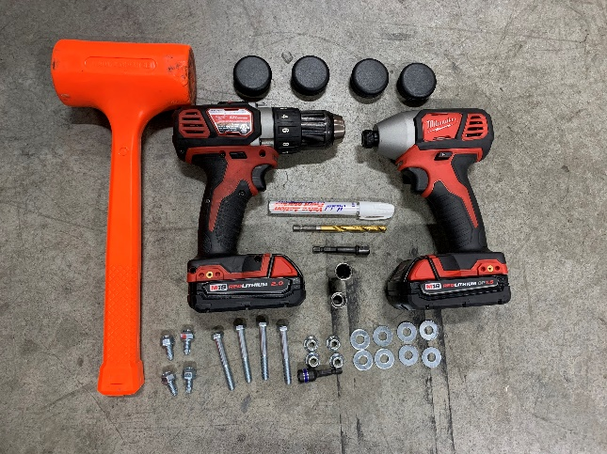
Figure 1

Passenger Side Installation:

- Start by inserting the plastic end caps using the rubber mallet as shown in figure 2.

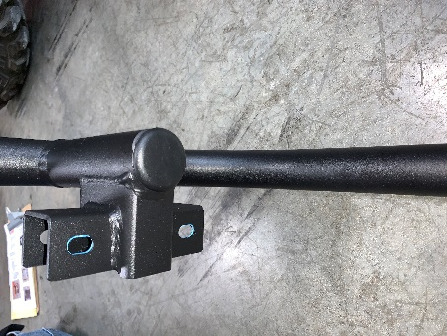
Figure 2
- After inserting the end caps take the passenger side rock slider bar as shown in figure 3 and set it even with the four bolt heads underneath the gas tank as shown in figure 4.
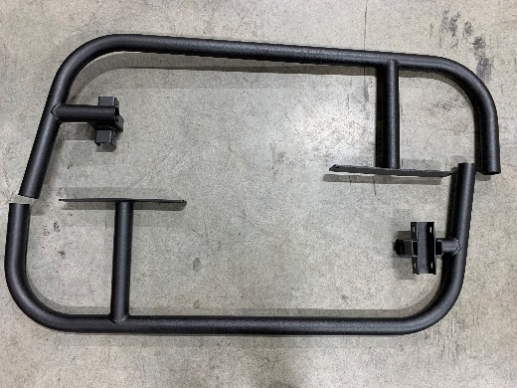
Figure 3

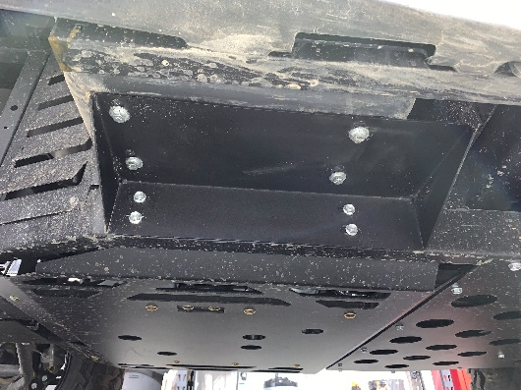
Figure 4

- After placed correctly use the paint marker to mark the drill point for the front side through bolt as shown in figure 5.
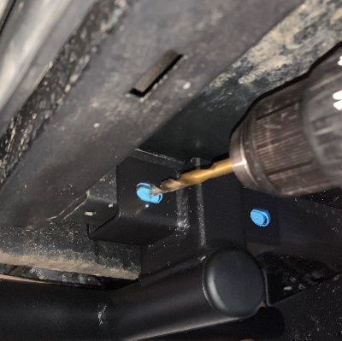
Figure 5

- After marking the drill point, move the rock slider bar away from the work area. Use a center punch in the middle of the mark, then using the 9/32 drill bit, drill the two pilot holes all the way through the frame.
- Then use the 23/64 drill bit in the same holes all the way through as shown in figure 5.
- After drilling is complete, take the four bolts out of the gas tank mount as shown in figure 6. Make sure to slowly let the gas tank down onto the tongue of the gas tank cap.
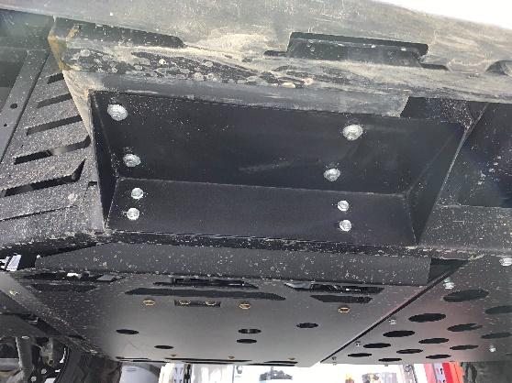
Figure 6
- Take the rock slider bar and line it up with the four existing holes for the gas tank mount. While lining it up, re-insert the four bolts that were removed.
- Move to the front mount. Then take two of the ½ inch bolts and nuts with four washers, using the ½ inch socket and wrench tighten with washers on both sides of the frame, that way no scratching will not occur.

Driver Side Installation:
- Start by inserting the plastic end caps using the rubber mallet as shown in figure 7.
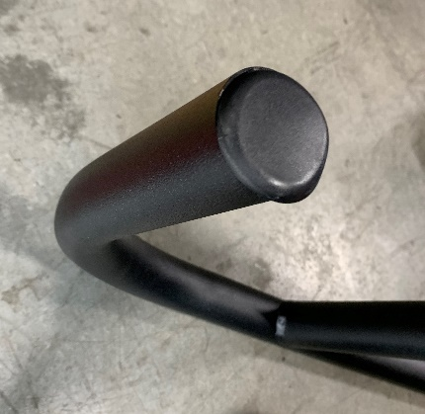
Figure 7

- Then take the rock slider bar and set it in place by sliding the front side mount onto the frame.
- After setting, mark the holes for the front and back mount, with the paint marker.
- Move the rock slider bar away from the work area and use a center punch in the middle of the marks.
- After using the center punch drill holes in the rear mounting area with the 9/32 drill bit as shown in figure 8.
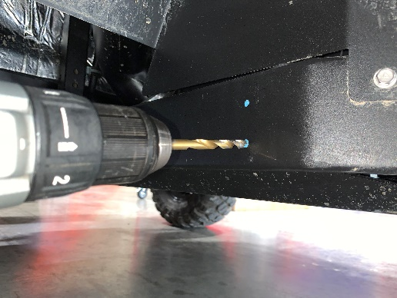
Figure 8
- Then move to the front mounts and use a center punch just like the rear mounts.
- After using the center punch use the 9/32 drill bit for the pilot holes, make sure to go all the way through the frame.
- Go back through the holes with the 23/64 drill bit to allow space for the bolts as shown in figure 9.
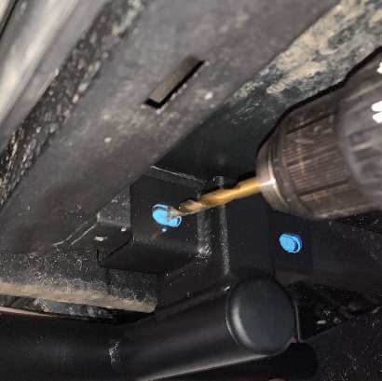
Figure 9
- Align the drilled holes with the rock slider mounting holes. Install the ½ inch self-tappers making sure not to tighten yet.
- Move to the front mount, then take two of the ½ inch bolts and nuts with four washers, using the ½ inch socket and wrench. Tighten with washers on both sides of the frame, that way no scratching will not occur as shown in figure 10.
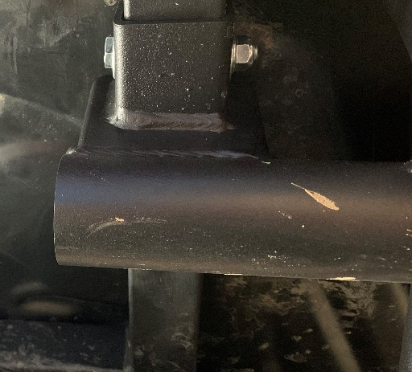
Figure 10
- After all self-tappers and bolts are put in place, tighten and test the bar to make sure no wiggling will occur.

