Safety:
- Ensure that the UTV is safely parked on level ground with the ignition off.
- Wear all appropriate PPE for the following procedures.

Note:
- Leave all hardware loose until the entire assembly is in its final position.

Assembly Components:
Ensure that you have all of these components before beginning the installation.

1 x Bumper
1 x Winch Plate
1 x Skid Plate
1 x Logo Bracket
1 x Winch Plate Bracket
1 x Light Bar Bracket
2 x Mounting Brackets (left and right)
1 x Hardware Kit

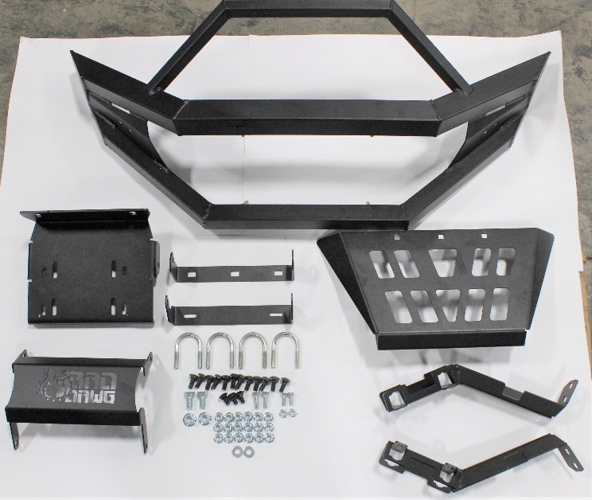
Figure 1: Kit Contents

Installation:

- Remove the upper and lower plastic grilles.
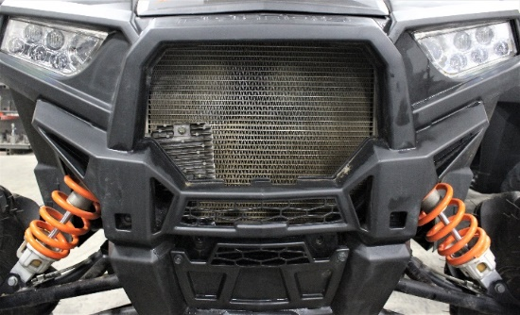
Figure 2: Upper Grille Removed
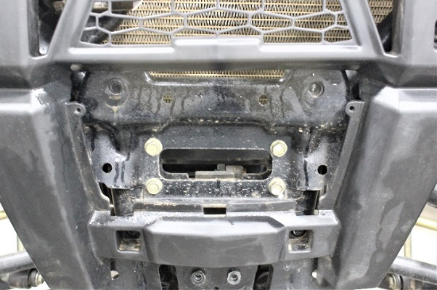
Figure 3: Lower Grille Removed
- If you will attach a winch, attach the winch plate and skid plate bracket to the lower bumper tabs using 2 carriage bolts and nylock nuts. If you will not add a winch, instead install the logo bracket to the bumper mounting tabs.
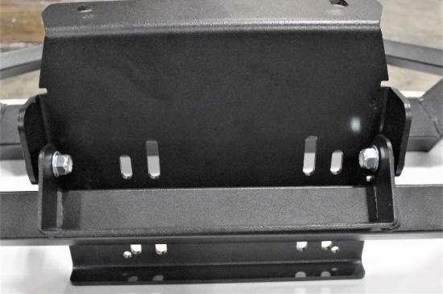
Figure 4: Winch Plate and Skid Plate Bracket to Bumper

- Attach the skid plate to the skid plate bracket using 3 carriage bolts and nylock nuts.
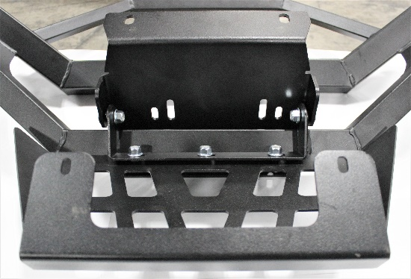
Figure 5: Skid Plate to Skid Plate Bracket
- (Optional) Attach the light bar bracket to the top bumper tabs in order to allow the mounting of a light bar.
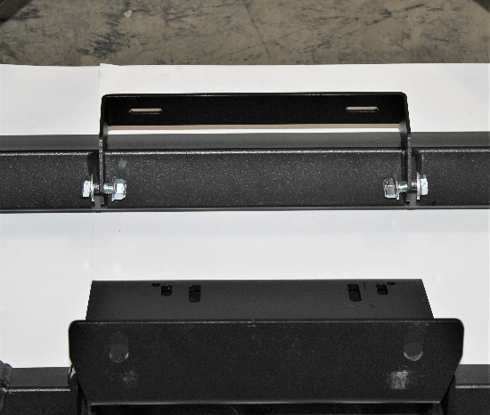
Figure 6: Optional Light Bar Bracket
- Using the included U-bolts, attach the mounting brackets to the frame member in the front wheel well.
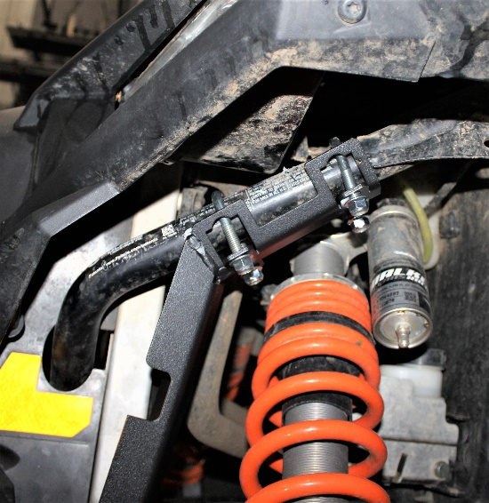
Figure 7: Mounting Bracket on Driver's Side
- Remove the two bolts holding the plastic cover at the front of the machine to allow for the mounting of the bumper.
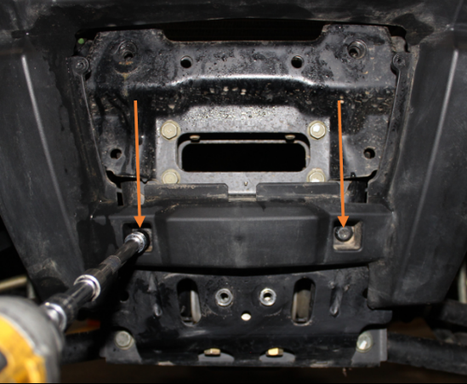
Figure 8: Plastic Cover Bolts
- If a winch is to be installed, attach the winch plate of the assembled bumper to the mounting holes located at the center of the front of the machine using the included hex bolts.
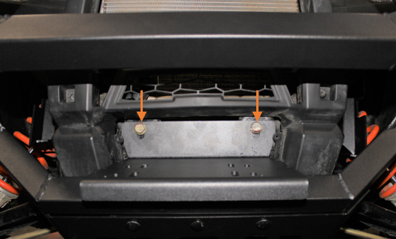
Figure 9: Winch Plate Mounting Bolts
- Attach the skid plate to the corresponding holes at the bottom of the machine using 2 hex bolts and nylock nuts.
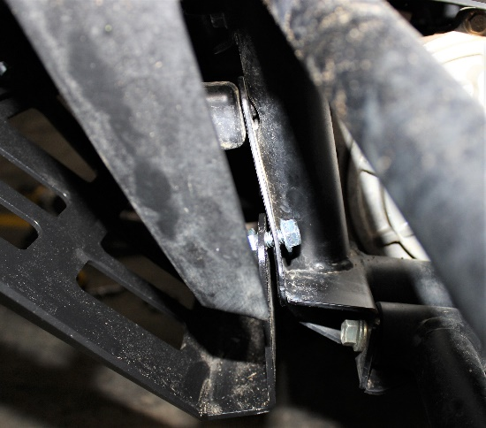
Figure 10: Skid Plate Mounting

- Secure the bumper to the mounting brackets with carriage bolts and nylock nuts.
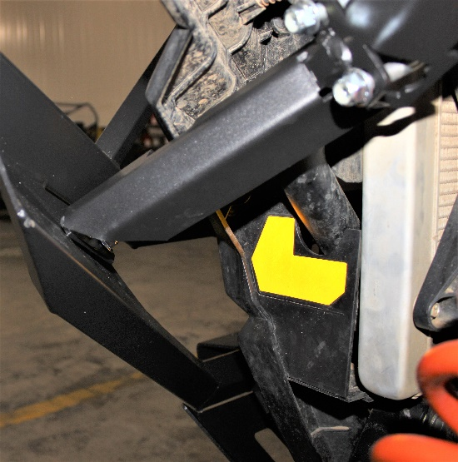
Figure 11: Driver's Side Mounting Bracket
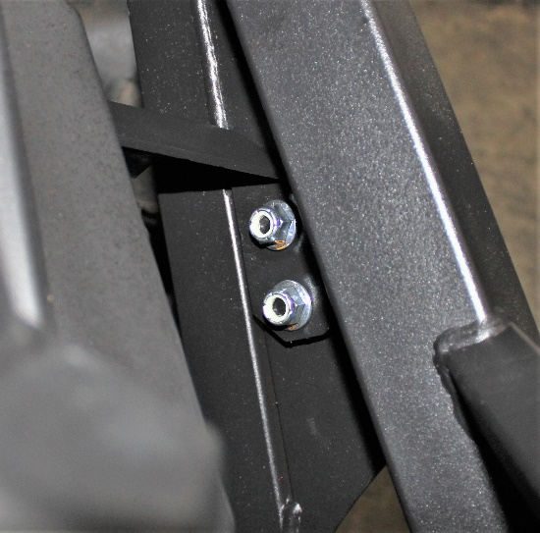
Figure 12: Mounting Bracket to Bumper Top
- Replace the bolts holding the plastic front cover in place, and replace the plastic grille pieces.
- Ensure that the bumper is level and straight before tightening all hardware securely.
- Enjoy your ride!
