**Safety:**

* Ensure that the UTV is safely parked on level ground with the ignition off.
* Wear all appropriate PPE for the following procedures.

**Note:**

* Leave all hardware loose until the entire assembly is in its final position.

**Assembly Components:**

Ensure that you have all of these components before beginning the installation.

**4 x Front Lift Brackets**

**4 x Rear Lift Brackets**

**8 x Spacer Tubes**

**12 x 3/8” Hex Bolts + Nylock Nuts**

**Spacer Washers**

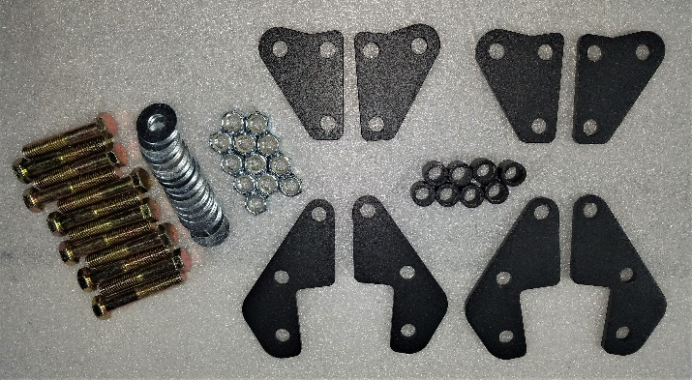

Figure 1: Kit Contents

**Recommended Equipment:**

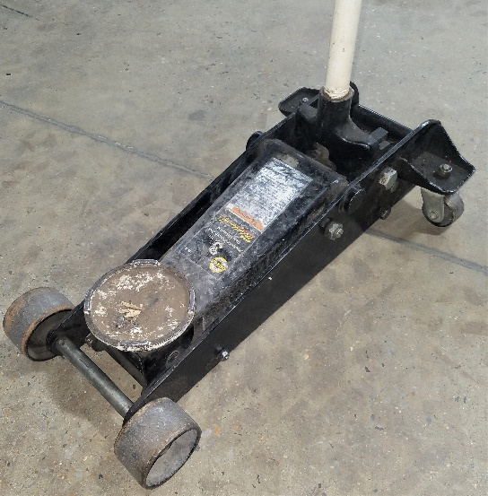

Figure 2: Heavy Lift Floor Jack

**Front Suspension Lift:**

**NOTE:** Perform this procedure completely for each side of the machine. Do not attempt to add the lift kit to both sides at the same time.

1. Position a suitable floor jack under the front differential skid plate of the machine. Raise the jack until it contacts the plate.

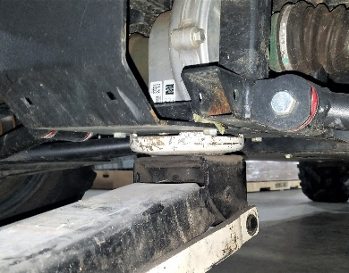

Figure 3: Floor Jack Position

1. Loosen the nut on the upper shock bolt on either side of the machine. Do not attempt to remove the bolt at this time.

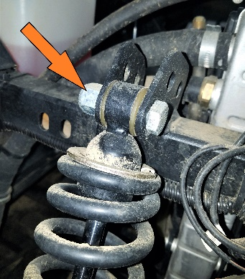

Figure 4: Upper Shock Bolt

1. Raise the machine using the floor jack slowly, testing the shock bolt each pump until it easily slips out of the shock mounting bracket, freeing the shock.

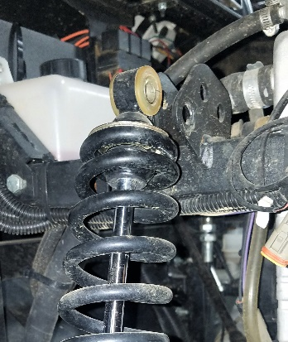

Figure 5: Upper Shock Bolt Removed

1. Lever the shock out of the way, and install the lift kit brackets in the order shown in Figure ????. Notice that one bracket is inside the stock brackets, and the other is outside of the stock brackets. This allows the spacer to take up the slack for the aftermarket part.

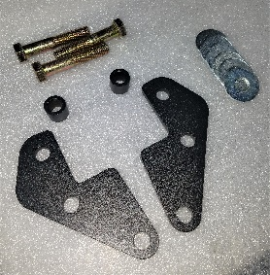

Figure 6: Individual Front Hardware

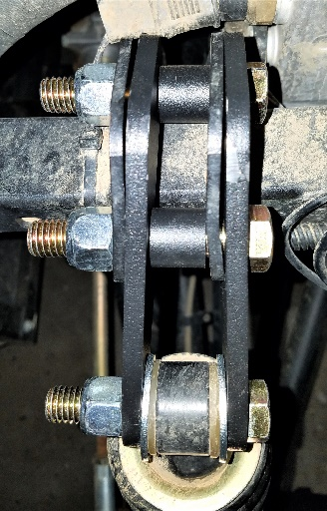

Figure 7: Installed Lift Hardware

1. Attach the shock to the lift kit. Make sure to add a washer to either side of the shock inside of the new mounting bracket. Tighten all hardware and slowly lower the machine onto the suspension. Repeat this procedure on the opposite side of the machine.

**Rear Suspension Lift:**

**NOTE:** Perform this procedure completely for each side of the machine. Do not attempt to add the lift kit to both sides at the same time.

1. Position a suitable floor jack under the rear differential skid plate of the machine. Raise the jack until it contacts the plate.
2. Loosen the nut on the upper shock bolt on either side of the machine. Do not attempt to remove the bolt at this time.

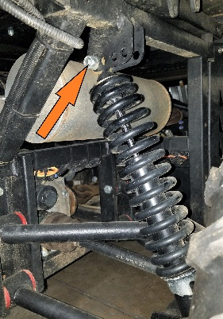

Figure 8: Upper Rear Shock Bolt

1. Raise the machine using the floor jack slowly, testing the shock bolt each pump until it easily slips out of the shock mounting bracket, freeing the shock.
2. Lever the shock out of the way, and install the lift kit brackets in the order shown in Figure ????. Notice that one bracket is inside the stock brackets, and the other is outside of the stock brackets. This allows the spacer to take up the slack for the aftermarket part.

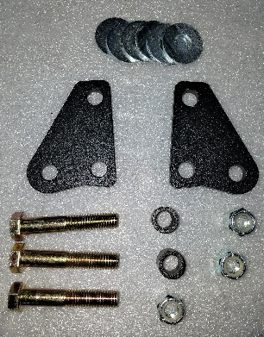

Figure 9: Rear Lift Hardware

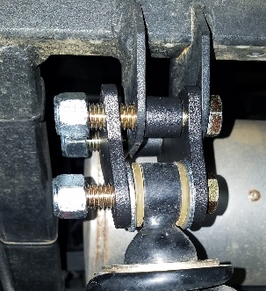

Figure 10: Rear Shock Hardware Order

1. Attach the shock to the lift kit. Make sure to add a washer to either side of the shock inside of the new mounting bracket. Tighten all hardware and slowly lower the machine onto the suspension. Repeat this procedure on the opposite side of the machine.