Safety:
- Ensure that the UTV is safely parked on level ground with the ignition off.
- Wear all appropriate PPE for the following procedures.

Note:
- Leave all hardware loose until the entire assembly is in its final position.

Assembly Components:
Ensure that you have all of these components before beginning the installation.

2 x CV Joint Protectors
2 x Mounting Brackets
1 x Hardware Kit

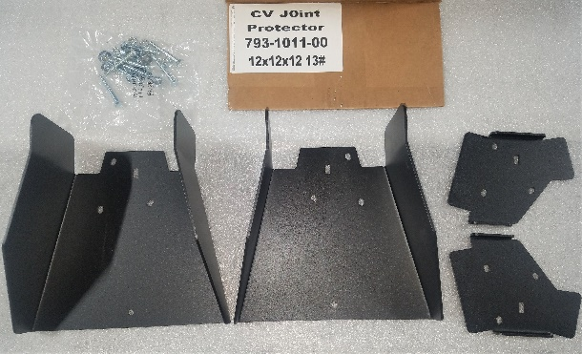
Figure 1: Kit Contents
Installation:

Note: The following procedures show the installation performed on the front-passenger-side of the machine.

- Remove the stock CV joint protector. Remove the two nuts and bolts holding the joint protector to the lower a-arm.
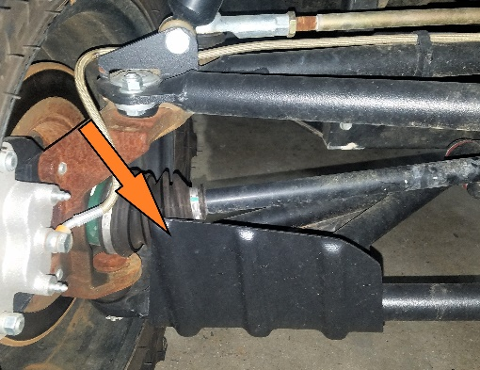
Figure 2: CV Joint Protector
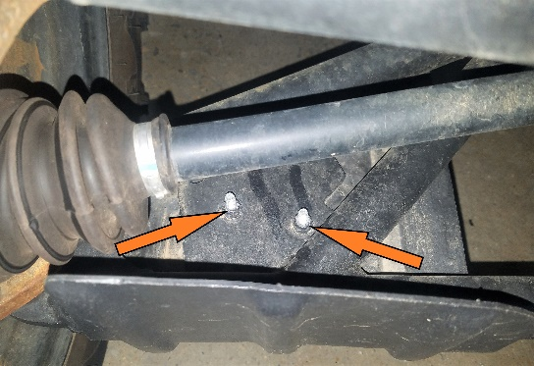
Figure 3: Stock CV Joint Bolts
- Match the correct metal CV joint protector mounting holes to the correct a-arm mounting location.
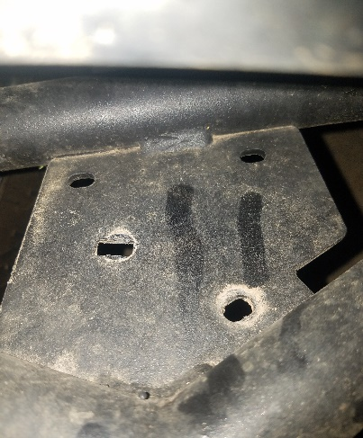
Figure 4: Joint Protector Mounting Location
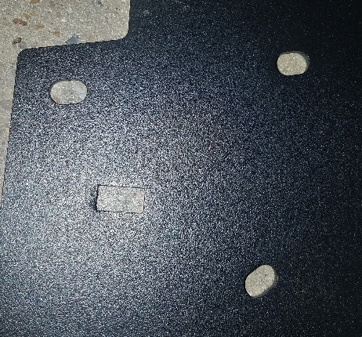
Figure 5: Joint Protector Mounting Holes
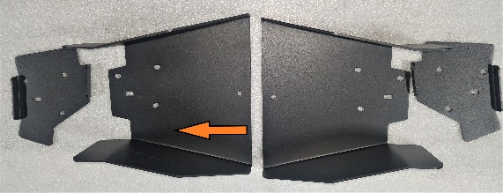
Figure 6: Passenger Side Indicate
- Position the new protector on the lower a-arm and insert the included hardware. Make sure that the carriage bolt is inserted into the square hole.
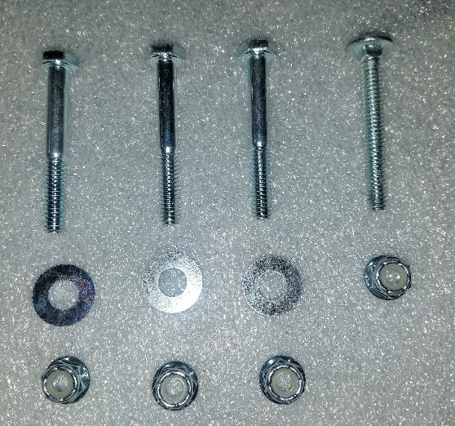
Figure 7: Mounting Bolts and Corresponding Nuts
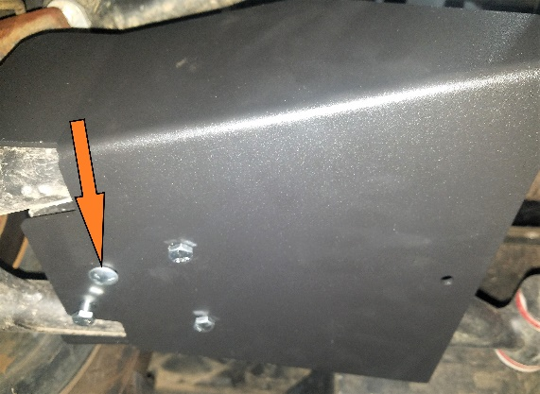
Figure 8: Protector Mounted (Carriage Bolt Indicated)
- Match the mounting bracket to the protector on the top side of the lower a-arm. Secure all of the bolts using the matching nuts. Make sure that the carriage bolt is secured with a washer and nylock nut.
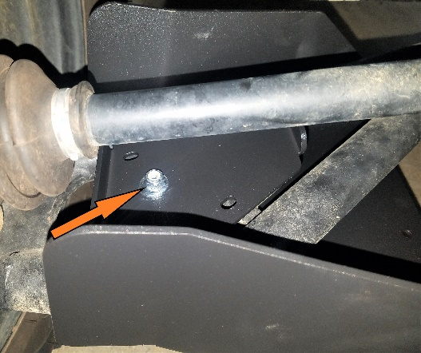
Figure 9: Top Bracket (Carriage Bolt Indicated)
- Repeat these procedures on the opposite side, ensuring that the hardware mirrors the passenger side setup.

