Safety:
- Ensure that the UTV is safely parked on level ground with the ignition off.
- Wear all appropriate PPE for the following procedures.

Note:
- Leave all hardware loose until the entire assembly is in its final position.

Assembly Components:
Ensure that you have all of these components before beginning the installation.

1 x Rear Rack
2 x Upper S-Brackets
2 x Upper Bracket Links
2 x Lower Brackets
1 x Hardware Kit

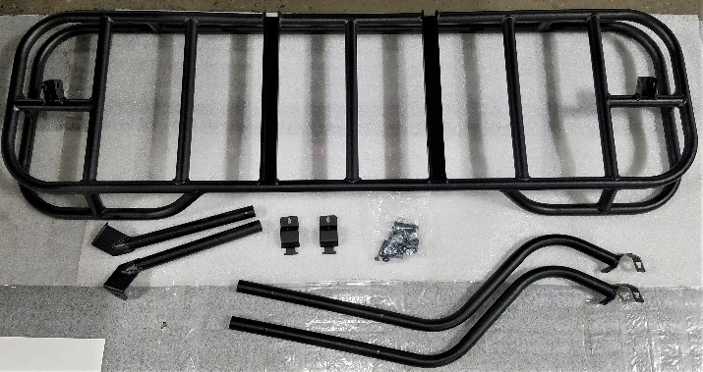
Figure 1: Kit Contents
Installation:

- Attach the Upper S-Brackets to the underside of the rear rack using the grooves. Make sure that the brackets curve towards the top of the rack.
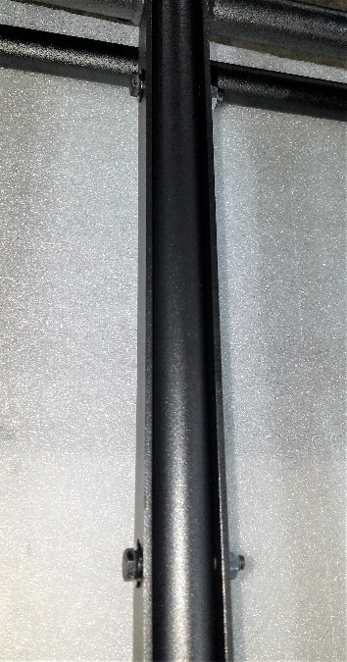
Figure 2: S-Bracket in Rack Groove

- Remove the nuts from the rear of the K-Brace section of the ROPS.
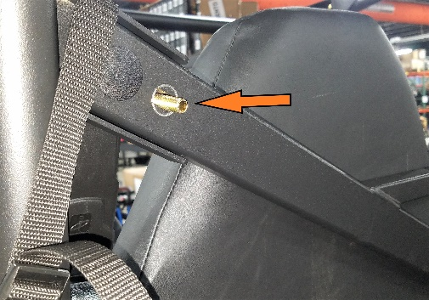
Figure 3: K-Brace Nut Removed
- Align the Upper S-Brackets with the rear section of the ROPS. Add the links to the mounting brackets and secure the bracket using a hex bolt and corresponding nut. Do not tighten the assembly yet.
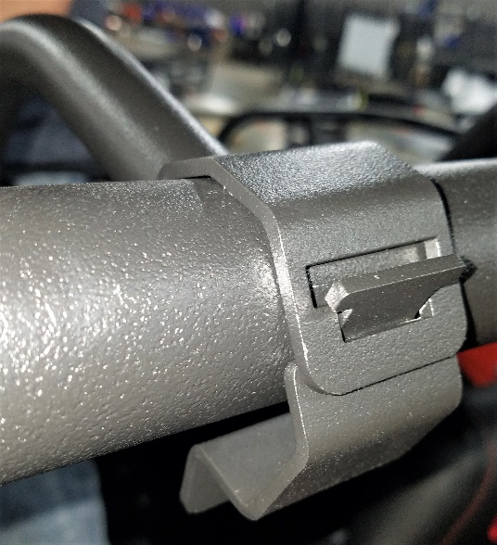
Figure 4: Upper S-Bracket with Link
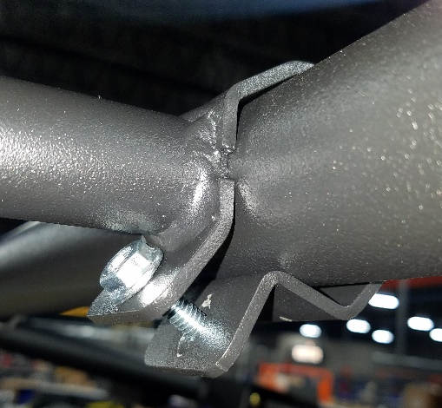
Figure 5: Secured Upper Bracket
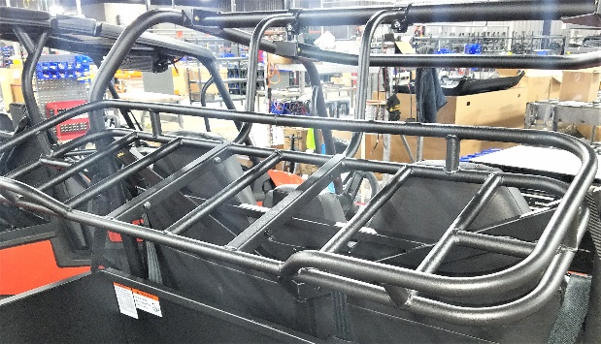
Figure 6: Rack Attached with Upper Brackets
- Lift the rack to allow room for the Lower Brackets to be installed onto the underside of the rack and rear of the K-brace. Make sure that the lower bracket tabs are facing the outside of the machine.
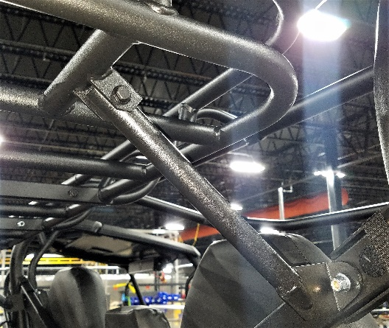
Figure 7: Lower Brackets Mounted
- Make sure that the assembly is properly centered and in its final position before tightening all hardware.
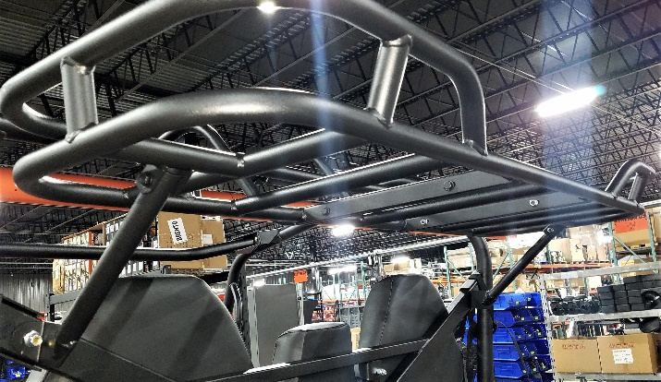
Figure 8: Install Complete

