Safety:
- Ensure that the UTV is safely parked on level ground with the ignition off.
- Wear all appropriate PPE for the following procedures.

Note:
- Leave all hardware loose until the entire assembly is in its final position.

Assembly Components:
Ensure that you have all of these components before beginning the installation.

1 x Rear Tube Bumper
2 x Mounting Brackets
1 x Hardware Kit

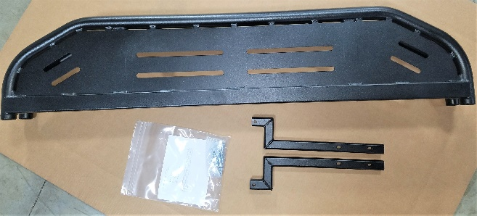
Figure 1: Kit Contents
Installation:

- The location for the bumper mounting brackets is found under the cargo bed directly in front of the tail gate.

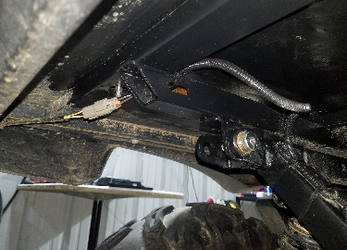
Figure 2: Left Mounting Location
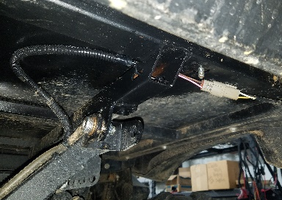
Figure 3: Right Mounting Location
- Insert a mounting bracket into each frame opening to align the bolt holes in the bracket with the ones in the frame. A rubber mallet may be needed in order to install the brackets correctly.

Note: The tolerances between the frame tubes and the mounting brackets is very tight and may require that the powder coating on the mounting brackets be ground/sanded off in order to get the brackets to fit. Exercise caution when grinding and do not remove an excessive amount of material.

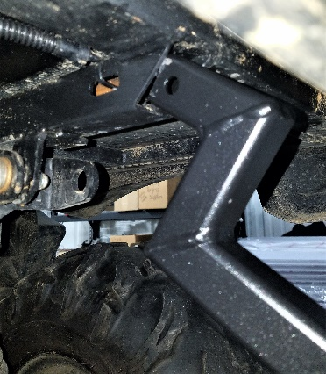
Figure 4: Inserting Bracket Prior to Grinding
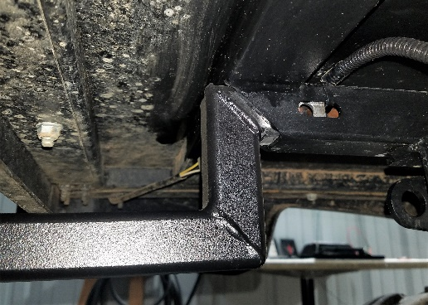
Figure 5: Bracket Inserted Correctly
- Secure each mounting bracket with a bolt and nut.
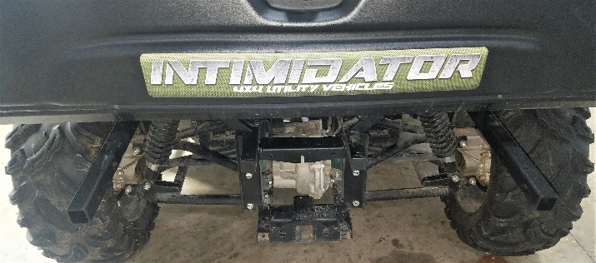
Figure 6: Installed Mounting Brackets
- Align the tube bumper mounting channels with the mounting brackets and align the holes on the brackets with those on the bumper. A rubber mallet may be needed to accomplish proper alignment.
- Secure the bumper to the mounting brackets using 4 bolts and 4 nuts.
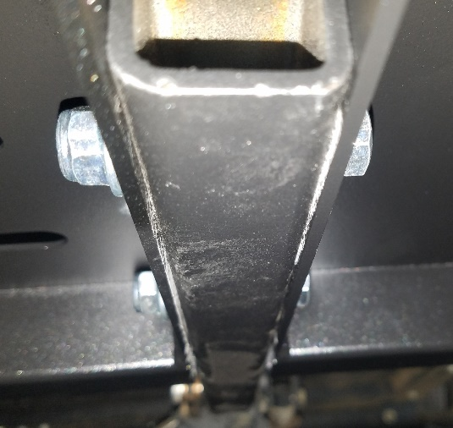
Figure 7: Bumper Mounting Bolts
- Tighten all hardware.
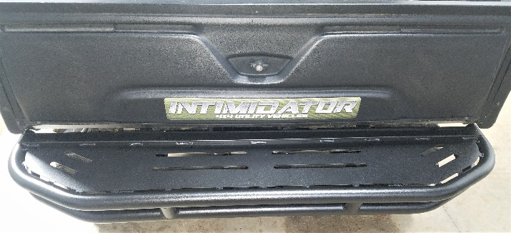
Figure 8: Installation Complete

