Safety:
- Ensure that the UTV is safely parked on level ground with the ignition off.
- Wear all appropriate PPE for the following procedures.

Assembly Components:
Ensure that you have all of these components before beginning the installation.

1 x Turn Signal Pod
1 x Horn Kit
1 x Hardware Kit

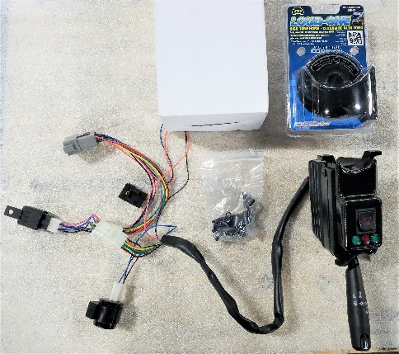
Figure 1: Kit Contents

Installation

- Disconnect the battery by first removing the negative (black) lead and then the positive (red) lead.

- Remove the gauge panel by removing the 4 machine screws located at the corners of the panel.
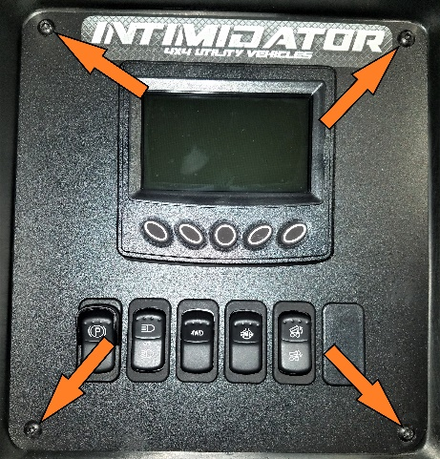
Figure 2: Gauge Panel Screws
- Locate the Green and Black wires that will be used for the horn. Route these wires back through the bulkhead hole to be used later. Remove zip ties where necessary. Replace the gauge panel.
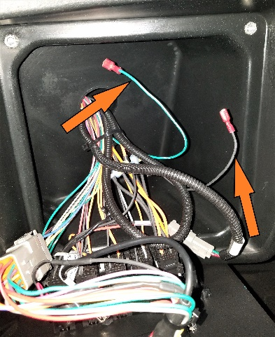
Figure 3: Horn Wires
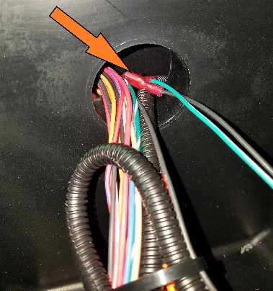
Figure 4: Horn Wire Routing
- Find a suitable location under the hood to mount the horn module. Attach the mounting bracket to the side of the horn, and then attach the horn assembly to the mounting location. Figure 5 shows a possible horn mounting location at the bottom of the battery bracket.
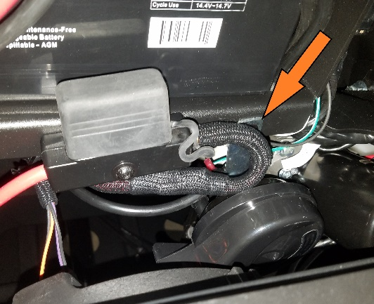
Figure 5: Example Horn Mounting Location
- Attach the horn wires to the contacts on the side of the horn.

- Adjust the steering wheel to its lowest position to allow room for the turn signal wiring harness.
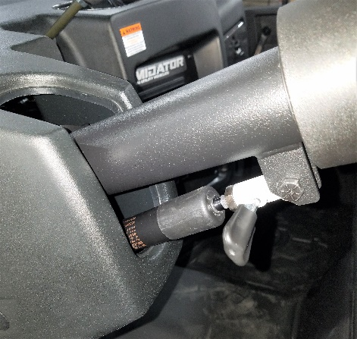
Figure 6: Lowered Steering Column
- Remove the bulky components from the turn signal wiring plugs. Route the turn signal wiring harness through the opening in the steering column on the left side of the steering shaft into the area under the hood. This step may require assistance from a second person.
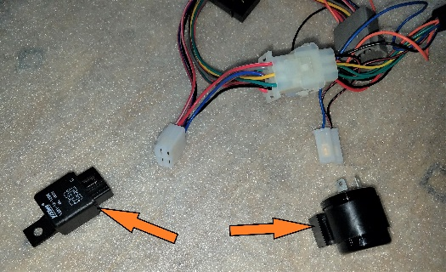
Figure 7: Wiring Harness Components
- Secure the turn signal pod to the steering column with the clamp. Make sure that the pod is in its final position before tightening the hardware, and that the pod is secured firmly to prevent movement during vehicle operation.
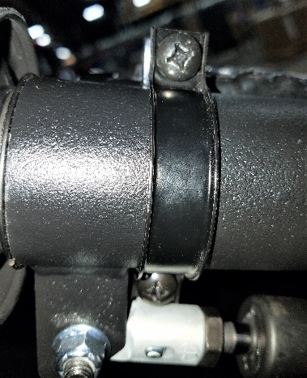
Figure 8: Turn Signal Pod Clamp
- Plug the turn signal wiring harness into the main frame wiring harness, and secure the wires away from moving parts using zip-ties.
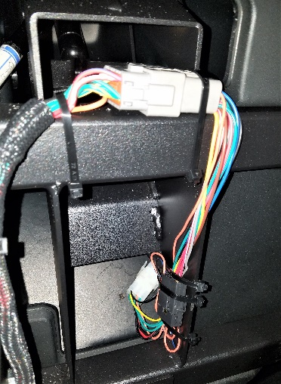
Figure 8: Connected and Secured Wiring
- Reconnect the battery leads to the battery (red lead first, then black). Turn the key to the “On” position and function test the turn signal pod.

Note: The pod will override the dash controls for the headlight high and low beams.

Questions

For any further questions or concerns, please contact the Intimidator Group at:

www.intimidatorutv.com/contact/us/

or

1525 White Drive
Batesville, AR 72501
855-307-0933

