Safety:
- Ensure that the UTV is safely parked on level ground with the ignition off.
- Wear all appropriate PPE for the following procedures.
- DO NOT attempt to install the light bar onto a plastic roof. Metal only.

Note:
- Leave all hardware loose until the entire assembly is in its final position.

These instructions are presented in two sections. The first set outlines the procedure for mounting the light bar onto the 1.75” roll over protective structure. The second set shows the installation of the light bar onto the metal roof. Both installation procedures involve the exact same wiring procedures. These instructions provide suggestions as to the placement of the light bar as well as efficient routing of the wiring harness. The final decision for placement and routing is in the hands of the customer. However, the installation guidelines remain the same.

Assembly Components:
Ensure that you have all of these components before beginning the installation. Refer to Figure 1: Kit Contents

1 x Light Bar
1 x Light Bar Cable
1 x Light Bar Hardware Kit
1 x Wiring Harness
1 x Dashboard Switch
*1 x ROPS Mounting Brackets (red box below)
*Optional at the time of purchase

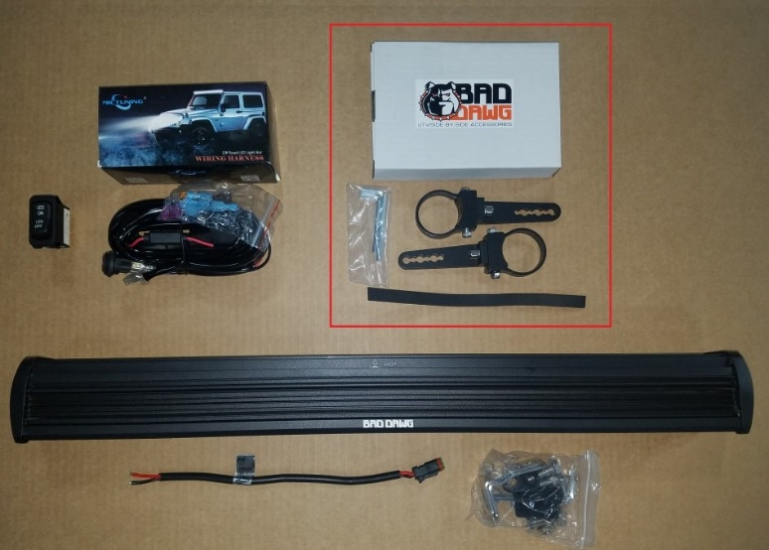
Figure 1: Kit Contents

Roof Mount Installation:

Note: Do not attempt to install the light bar onto a plastic roof. Install into a metal roof only.

- Ensure that the mounting location for your light bar will accommodate both the light bar and the mounting brackets. Remove any accessories that will interfere with the safe mounting/operation of the light bar.

- Using the hardware from the light bar hardware kit, fasten the mounting brackets to either side of the light bar with a rubber grommet between the bracket and the light bar. The brackets will face the bottom of the light bar. The top of the bar is indicated by the Bad Dawg logo.

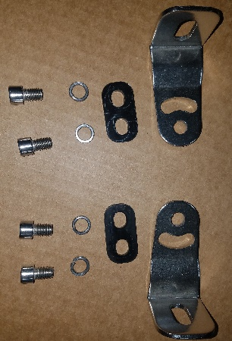
Figure 2: Roof Mounting Hardware

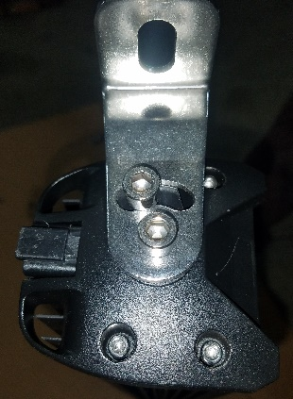
Figure 3: Roof Mounting Bracket
- Position the light bar assembly on the roof in the intended mounting position. It is recommended that the mounting brackets align with the bend line at the front of the roof and that a tape measure is used to ensure that the bar is perfectly centered. Once in position, mark the locations of the holes for future drilling.

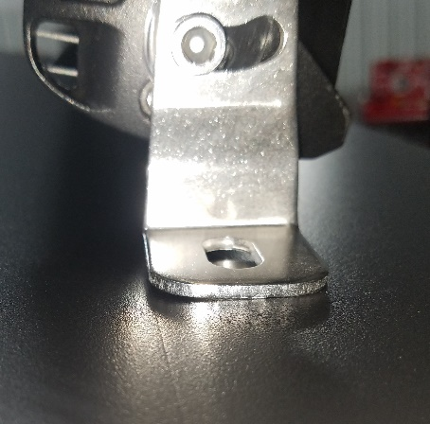
Figure 4: Bracket in Line with Bend Line

- Remove the light bar from the roof and drill a 3/8” hole at one of the hole marks (It may be easier to begin with a smaller drill bit and work up to a 3/8”)
- Once the first hole is drilled, place the light bar back onto the roof and fasten the appropriate mounting bracket to the drilled hole. Make sure to place the rubber pad in-between the mounting bracket and the roof with the checkered side down, towards the roof.

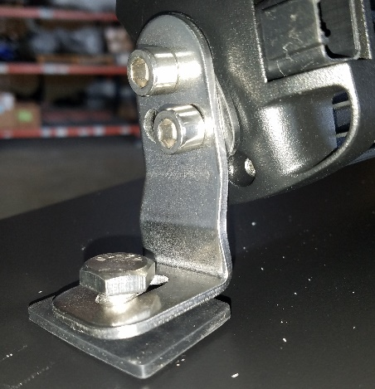
Figure 5: Mounting Roof Bracket
- Make sure that the marked location for the second hole is accurate using the mounting bracket on the other end of the light bar. Once you are certain that the mounting location is correct, drill another hole and attach the second mounting bracket in the same manner as the first.

Roll Cage Mount Installation:

- Ensure that the mounting location for your light bar will accommodate both the light bar and the mounting brackets. Remove any accessories that will interfere with the safe mounting/operation of the light bar.
- Remove the loops from the mounting brackets of the mounting bracket assembly.

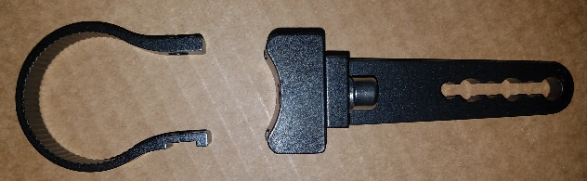
Figure 6: Roll Bar Mounting Assembly
- Utilizing the two holes at the end of the light bar and the hole farthest up the mounting bracket, fasten the brackets to the light bar with the included hardware.

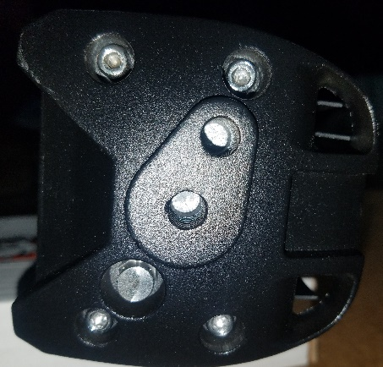
Figure 7: Light Bar Mounting Holes
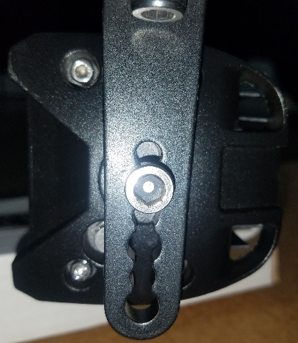
Figure 8: ROPS Bracket on Light Bar
- Place the mounting loops onto the roll bar with the notches facing the direction that the light will face and then fasten the light bar to the loops using the included hardware. Place the nuts into the notches for ease of tightening the assembly.

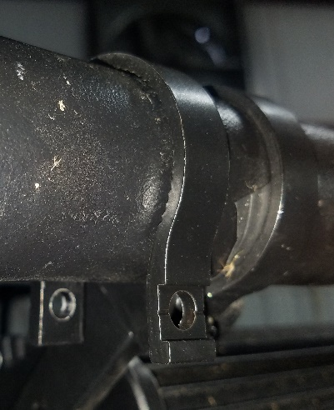
Figure 9: ROPS Loop Notch Detail
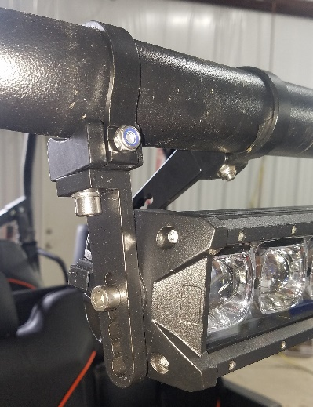
Figure 10: Properly Mounted Light

Wiring Installation:
These instructions are recommendations meant to accommodate a wide range of machines. It is perfectly acceptable to avoid drilling holes in components in favor of routing wires around them.

- Insert the light bar cable into the receptacle on the back of the light bar. 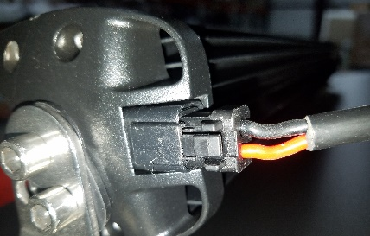
Figure 11: Light Bar Cable Jack
- If the cable will be fed through a hole in the roof or other structure, do so before attaching the spade connectors to the ends of the red and black wire leads. You may need to clip off the solder in order to allow room for the wires to fit into the spade connectors.

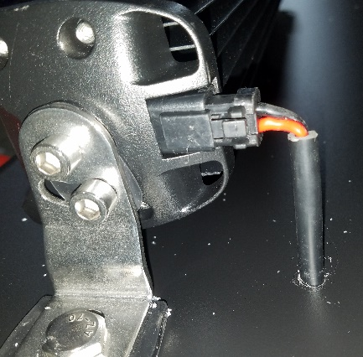
Figure 12: Routing Cable Through Roof
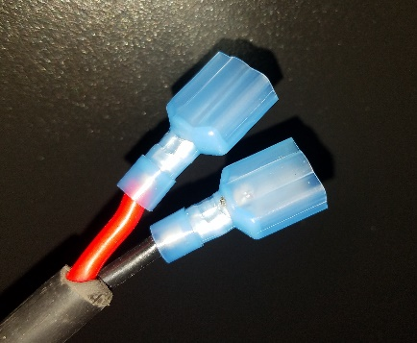
Figure 13: Spade Connectors on Light Bar Cable
- If a single light bar is being installed, wrap the secondary wiring lead in electrical tape against the wiring harness. The primary connection is shown to the right of Figure 14.
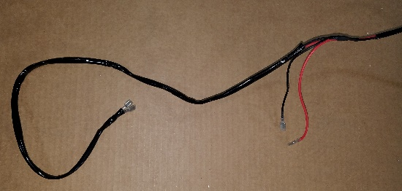
Figure 14: Primary Connectors on Left
- Route the female spade connector of the wiring harness through the hood and/or any discrete areas in the machine towards the light bar cable. Connect the spade connectors to their corresponding colors.
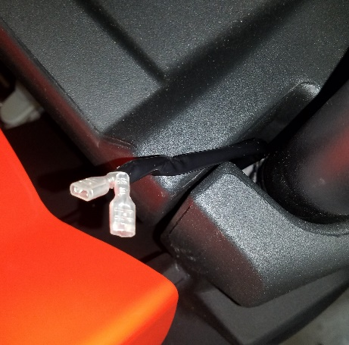
Figure 15: Routing Example
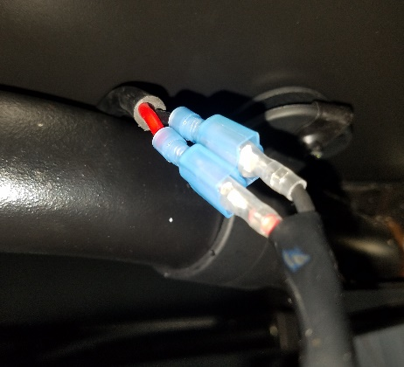
Figure 16: Harness to Light Cable Connection
- Route the other end of the harness through the battery compartment.
- Before connecting the leads to the battery, replace the 5A fuse on the battery leads with an included 15A fuse.
- Remove the dash panel from your machine and remove one of the existing switch hole covers.

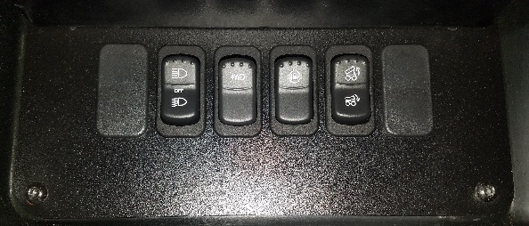
Figure 17: Dash Switches
- The wiring harness comes with a factory switch connected to three wires. Remove this switch and route the wires through the open switch hole in the dash plate.
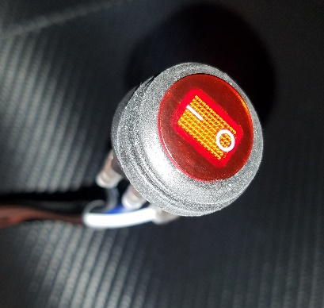
Figure 18: Example Stock Switch
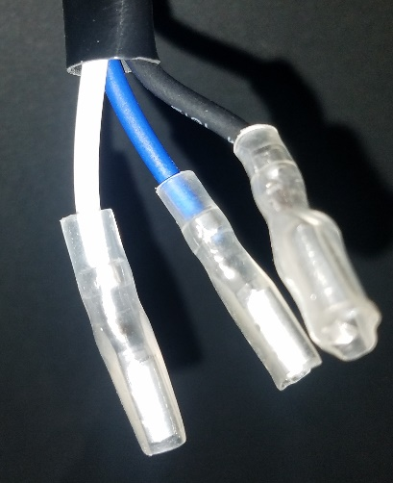
Figure 19: Switch Connectors (stock switch removed)
- Attach the wires to the included dash switch as indicated in Figure 20: Proper Switch Wiring.

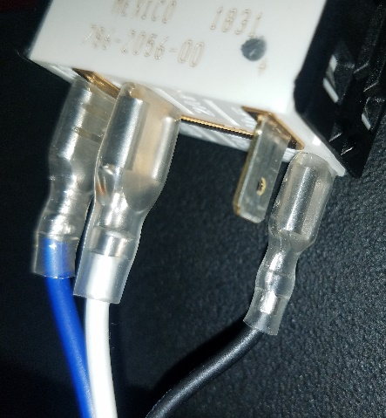
Figure 20: Proper Switch Wiring
- Press the switch into the plate and then re-install the plate into the dash.
- Connect the wire harness battery leads to the battery. Red on positive, black on negative.
- Test the light bar for function. Ensure that all hardware is tightly secured.

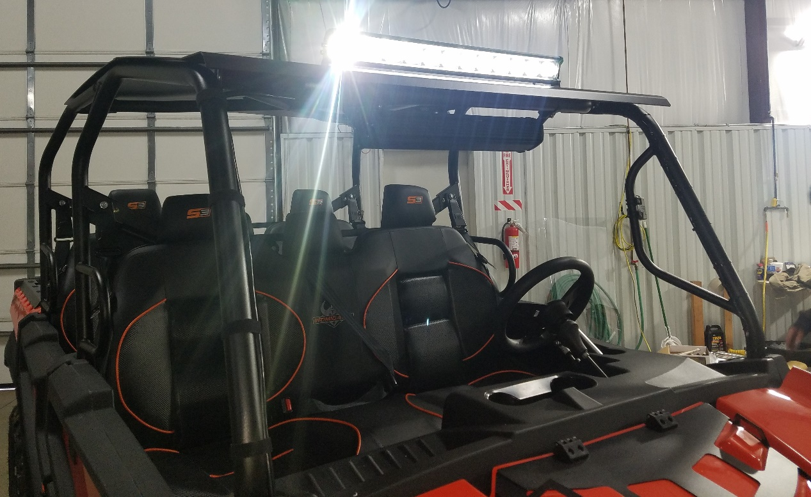
Figure 21: Finished Installation

