**Safety:**

* Ensure that the UTV is safely parked on level ground with the ignition off.
* Wear all appropriate PPE for the following procedures.

**Note:**

* Leave all hardware loose until the entire assembly is in its final position.

**Assembly Components:**

Ensure that you have all of these components before beginning the installation.

**1 x Square Tube Bumper**

**2 x Mounting Brackets (left and right)**

**1 x Accent Plate**

**2 x Light Hole Cover Plates**

**1 x Hardware Kit**

**Installation Procedure:**

1. Locate the mounting holes on the cargo bed frame on the underside of the cargo bed.

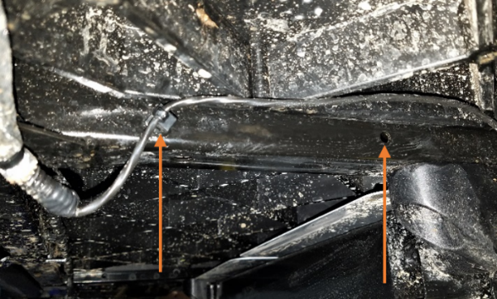

Figure 1: Right Side Bed Frame Holes

1. Drill out the mounting holes to accommodate the 5/16” bolts. The small wiring harness on the right side must be relocated and secured with a zip tie or other secure method.

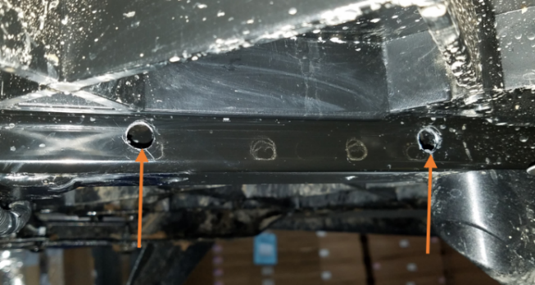

Figure : Drilled Out Bed Frame Holes

1. Mount the left and right brackets to the drilled-out bed frame holes using the included 5/16” bolts and corresponding nuts. Reference Figure 4 for the correct placement.

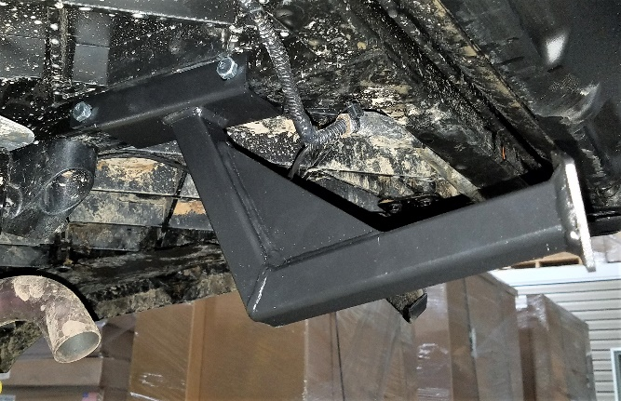

Figure : Right Side Mounting Bracket

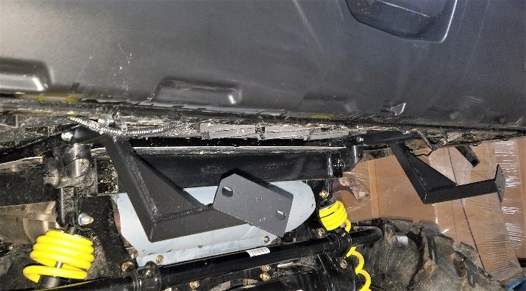

Figure : Mounting Brackets

1. Mount the accent plate to the inside of the bumper using the included machine screws and their corresponding nuts.

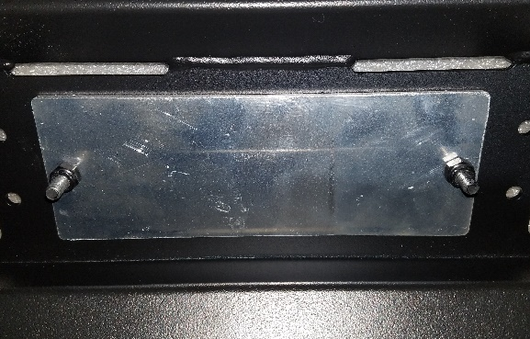

Figure : Accent Plate Inside the Bumper

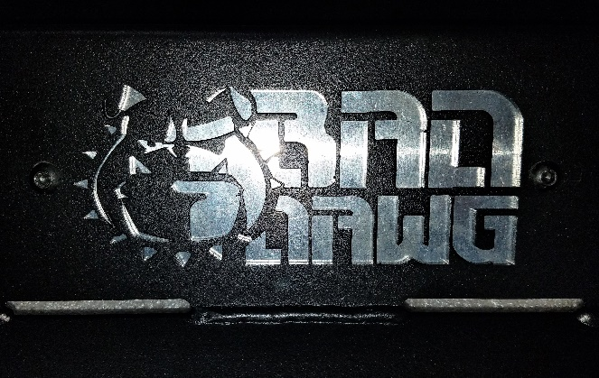

Figure : Accent Plate Outside Bumper

1. Mount the bumper to the brackets with the included carriage bolts and nuts.

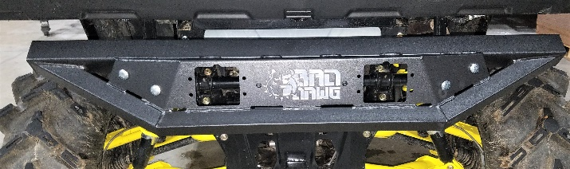

Figure : Bumper Mounted on Brackets

1. At this point you may either install the light hole covers over the openings in the bumper, or install lights into the bumper (you may purchase these lights at [www.baddawgaccessories.com](http://www.baddawgaccessories.com)). Figure 8 illustrates the light hole cover installation, and Figure 9 shows lights properly installed.

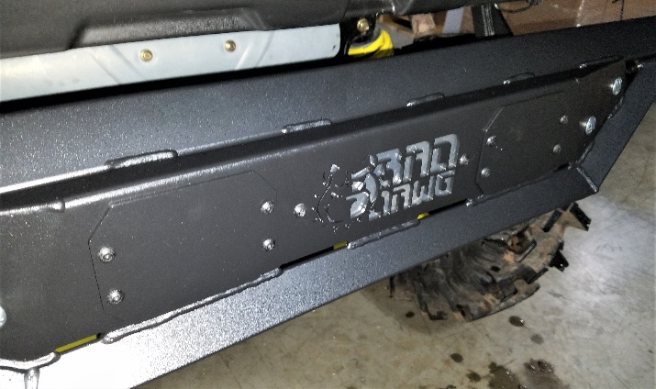

Figure : Light Hole Covers

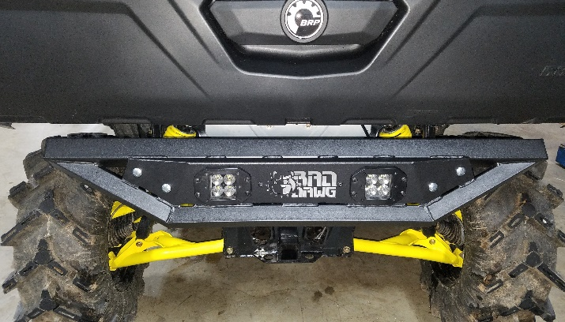

Figure : Bumper with Lights

1. Ensure that all hardware is tightened securely before operating your machine.

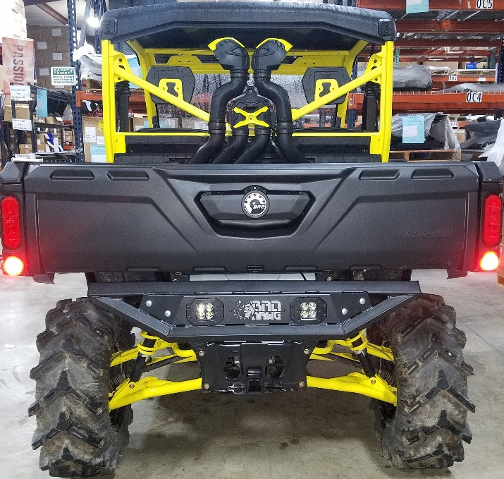

Figure : Installation Complete