Safety:
- Ensure that the UTV is safely parked on level ground with the ignition off.
- Wear all appropriate PPE for the following procedures.

Note:
- Leave all hardware loose until the entire assembly is in its final position.

Assembly Components:
Ensure that you have all of these components before beginning the installation.

1 x Bumper
1 x Skid Plate
1 x Support Bracket
1 x Accent Plate
1 x Hardware Kit

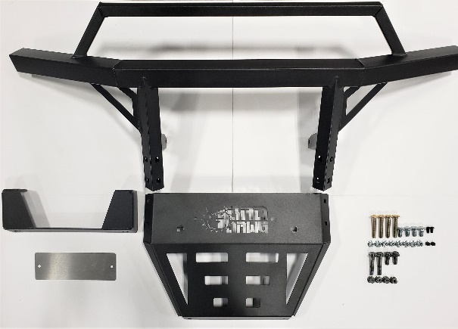
Figure 1: Kit Contents
Installation:

- Remove the factory bumper.
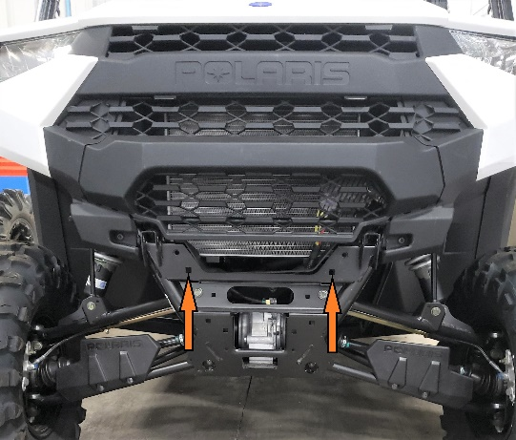
Figure 2: Stock Bumper Removed
- Attach the bumper support bracket to the machine using the 2 factory bolt holes indicated in Figure 2.
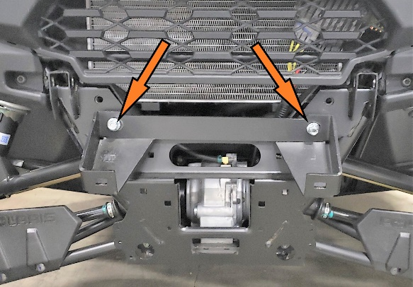
Figure 3: Bumper Support Bracket Mounted
- Attach the skid plate to the bumper using the included 3/8” carriage bolts and nuts.
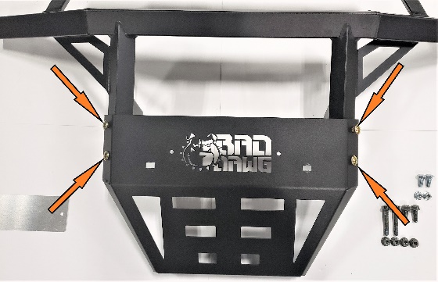
Figure 4: Skid Plate Mounted to Bumper
- Attach the accent plate to the inside of the Bad Dawg logo using the included machine screws and nuts.
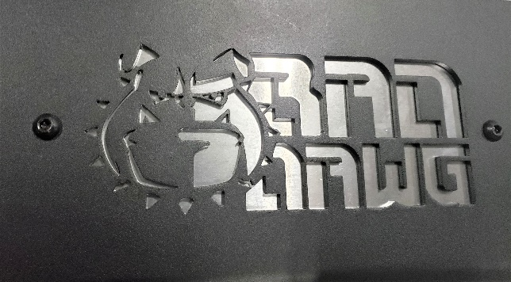
Figure 5: Accent Plate Behind Logo

- Attach the skid plate to the bottom bolt holes located at the bottom of the machine.
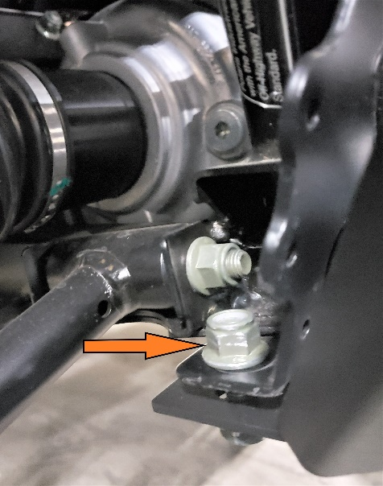
Figure 6: Skid Plate Lower Mounting
- Attach the face of the bumper to the bumper support bracket. At this point align the bumper with the factory bumper mounting location.
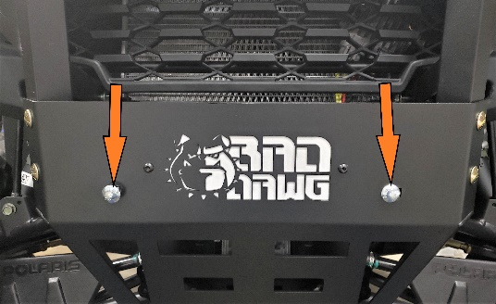
Figure 7: Skid Plate to Support Bracket
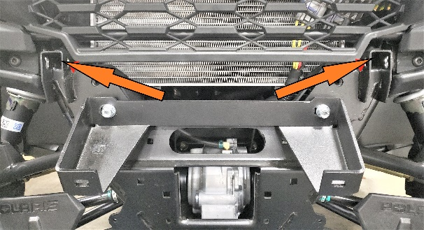
Figure 8: Stock Bumper Mounting Location

- Attach the bumper to the factory mounting location using 3/8” bolts and nuts.
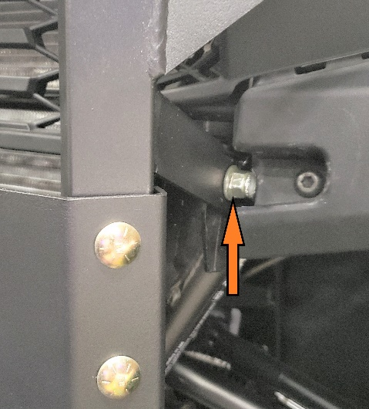
Figure 9: Bumper Mounting Bolt
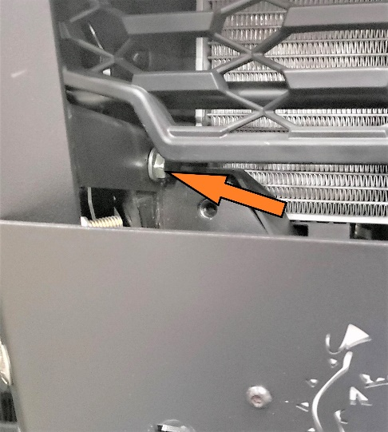
Figure 10: Bumper Mounting Bolt Inside
- Ensure that the bumper is properly aligned and straight before tightening all hardware securely.

- Enjoy your ride!

