Safety:
- Ensure that the UTV is safely parked on level ground with the ignition off.
- Wear all appropriate PPE for the following procedures.

Note:
- Leave all hardware loose until the entire assembly is in its final position.

Assembly Components:
Ensure that you have all of these components before beginning the installation.

1 x Windshield
1 x Trimlock Seal
8 x 1.7” Roll Bar Clamps
1 x Windshield Wiper
1 x Wiper Lever
1 x Hardware Kit

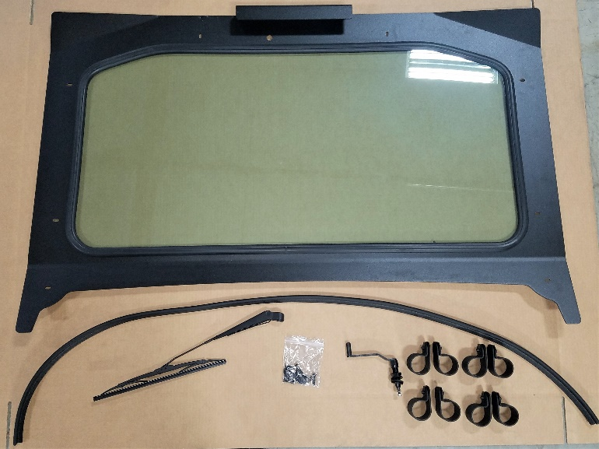
Figure 1: Windshield Kit Contents

Windshield Installation:

- Install the Trimlock seal onto the bottom edge of the windshield. Trim the excess length of the Trimlock to match the windshield.

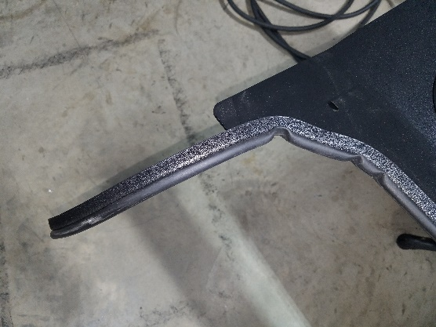
Figure 2: Excess Trimlock
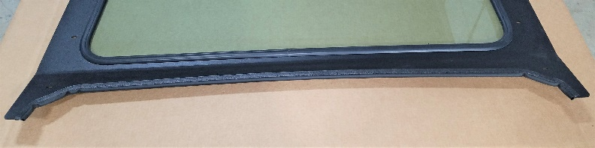
Figure 3: Properly Installed Trimlock
- Place the windshield onto the machine. Make sure that the bottom edge of the windshield is flush with the plastic hood.
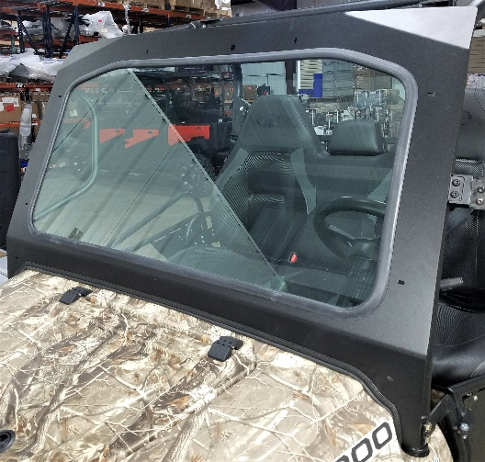
Figure 4: Positioned Windshield
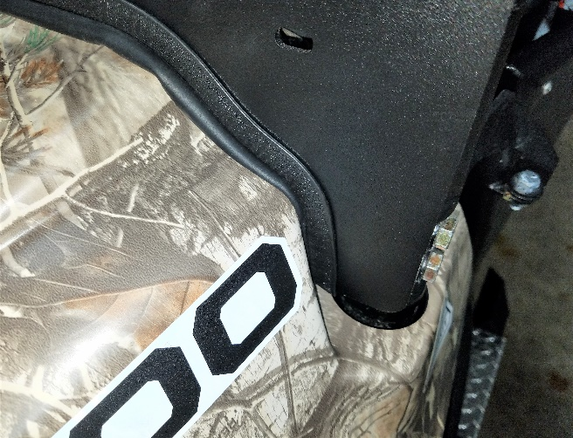
Figure 5: Windshield Notch
- Wrap the clamps onto the roll cage and align them with their corresponding windshield holes. Secure the windshield to the clamps using the 8 included Hex head machine screws and 8 flat washers.
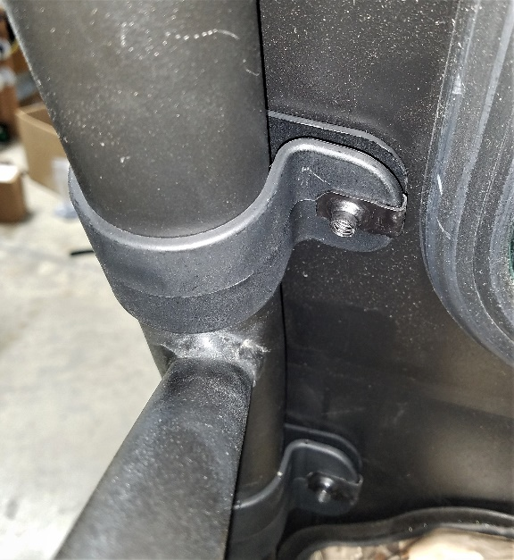
Figure 6: Clamp Positioning

Windshield Wiper Installation:
- Place the hardware onto the windshield wiper lever in the order indicated in Figures 7-10. If the machine already has a top, the lever must be adjusted so that it does not interfere with the top. Notice also how the interior requires an additional nut if a top is installed.
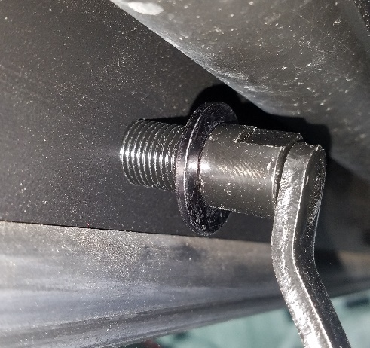
Figure 7: Interior Lever Hardware
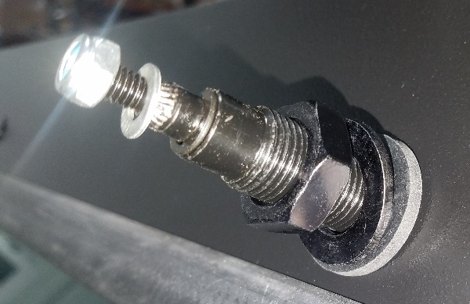
Figure 8: Exterior Lever Hardware
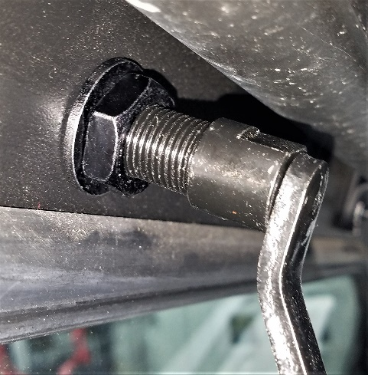
Figure 9: Interior with Plastic Top
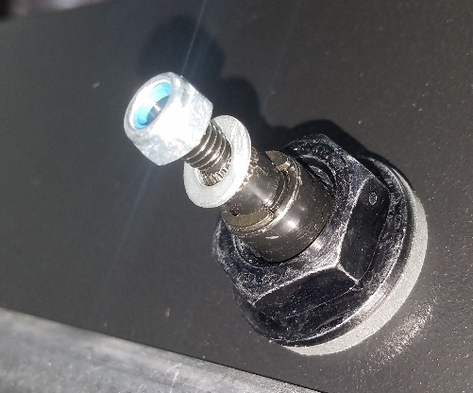
Figure 10: Exterior with Plastic Top
- Tighten the exterior nut to slightly compress the plastic washer between the windshield and the exterior nut. Use a wrench to hold the lever shaft in place while tightening the exterior nut. Position the notches in the shaft vertically before installing the wiper.
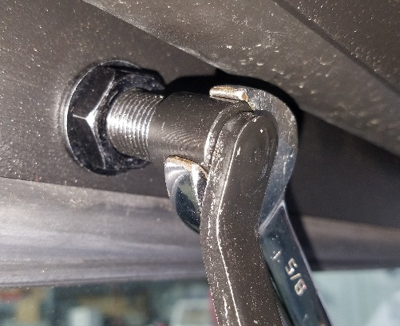
Figure 11: Tightening Exterior Nut
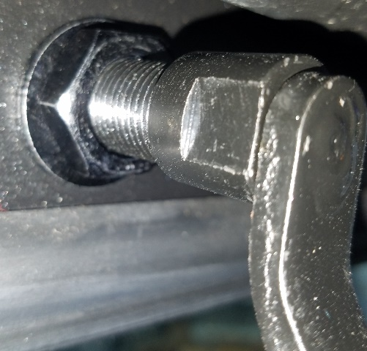
Figure 12: Final Shaft Position
- Remove the outermost nut from the windshield wiper shaft, position the wiper onto the shaft and then tighten the nut to secure the wiper to the assembly.
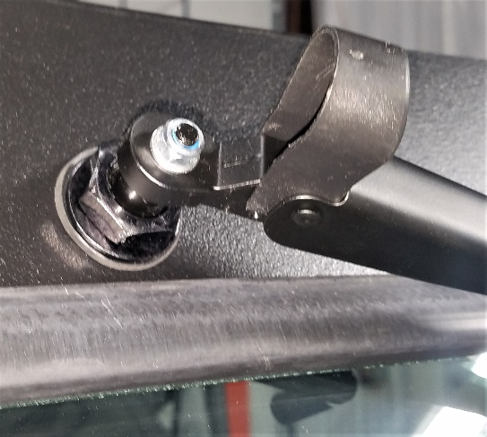
Figure 13: Wiper onto Shaft
- Make sure that the wiper and lever align in a way that allows for convenient operation.
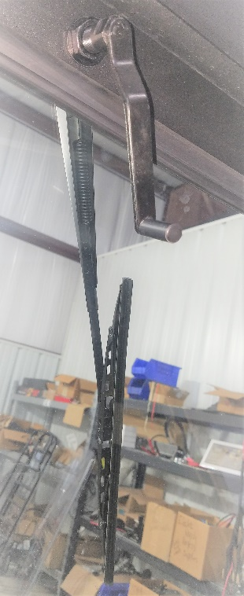
Figure 14: Final Alignment

