Safety:
- Ensure that the UTV is safely parked on level ground with the ignition off.
- Wear all appropriate PPE for the following procedures.

Note:
- Leave all hardware loose until the entire assembly is in its final position.

Assembly Components:
Ensure that you have all of these components before beginning the installation.

1 x Rear Top Panel
1 x Front Top Panel
1 x Plastic Rivet Pack

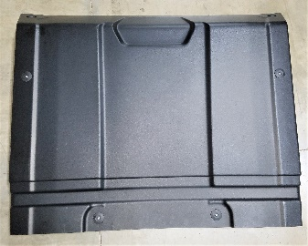
Figure 1: Rear Top Panel
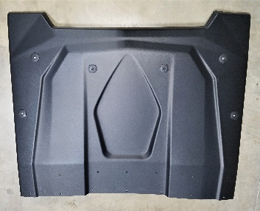
Figure 2: Front Top Panel
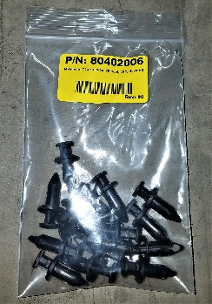
Figure 3: Plastic Rivet Pack

Installation:

- Install the Rear Top Panel. Align the Rear Top Panel with the rear members of the machine’s roll cage. Use a rubber mallet or other soft hammer to secure the clips onto the roll cage as shown.
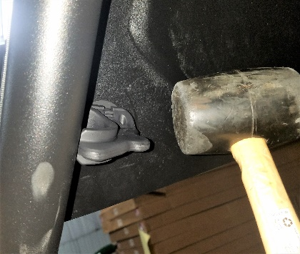
Figure 4: Mallet Securing Clip
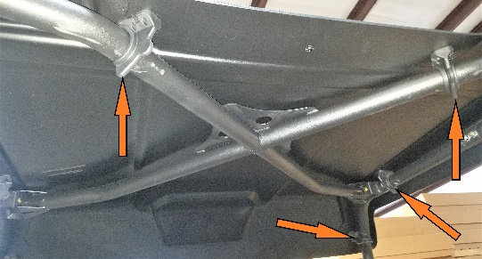
Figure 5: Clip Locations (Driver's side to the right)
- Install the Front Top Panel. Align the Front Top Panel with the front section of the machine’s roll cage. Secure the clips onto the roll cage using a rubber mallet or other soft hammer.
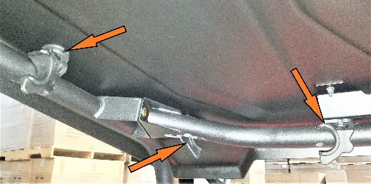
Figure 6: Driver's Side Front Clip Position
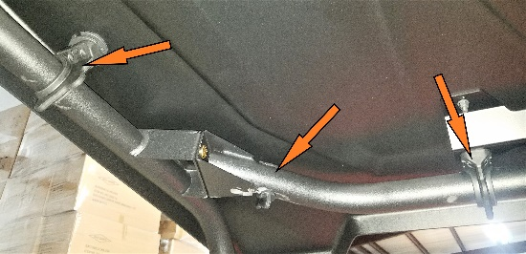
Figure 7: Driver's Side Front Clips Installed
- Using a 19/64” drill bit, drill out each hole on the top of the roof where the two panels overlap. There are also holes on either side of the panels. The holes should be just large enough to accept the plastic rivets.
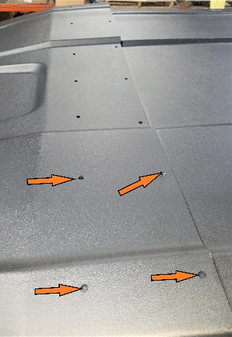
Figure 8: Holes in the Front Top Panel (several indicated)
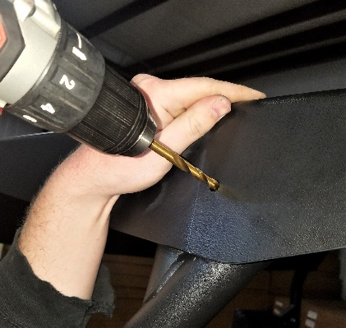
Figure 9: Drilling out Holes

- In each of the drilled holes, install a plastic rivet to secure the top panels together. A rubber mallet may be needed to fully seat the rivets.
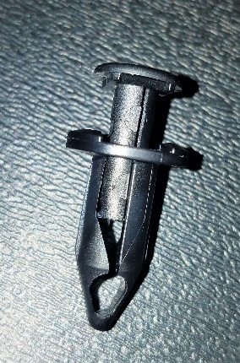
Figure 10: Plastic Rivet
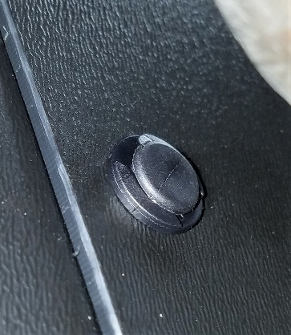
Figure 11: Plastic Rivet Installed
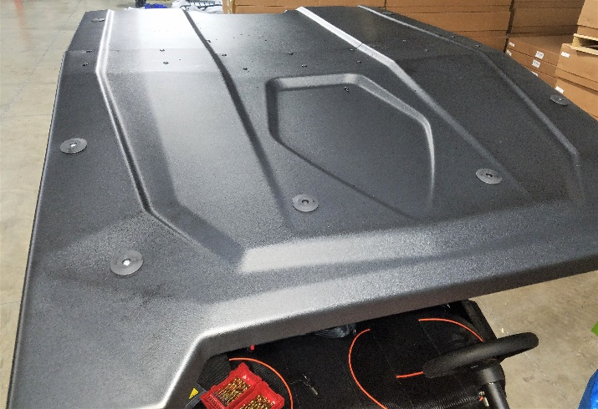
Figure 12: Install Complete

