Safety:
- Ensure that the UTV is safely parked on level ground with the ignition off.
- Wear all appropriate PPE for the following procedures.

Note:
- Leave all hardware loose until the entire assembly is in its final position.

Assembly Components:
Ensure that you have all of these components before beginning the installation.

1 x Rear Square Tube Bumper
1 x Logo Plate
1 x Accent Plate
2 x Mounting Brackets (left and right)
2 x Slide Brackets
1 x Hardware Kit
2 x 4” Pod Lights with Wiring

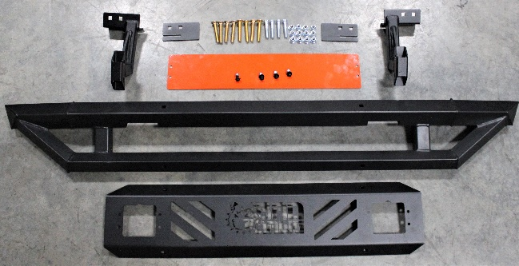
Figure 1: Kit Contents
Bumper Installation:

- Remove the tailgate by lowering the tailgate and removing the two retaining hex bolts on the inside of the hinge of the tailgate.
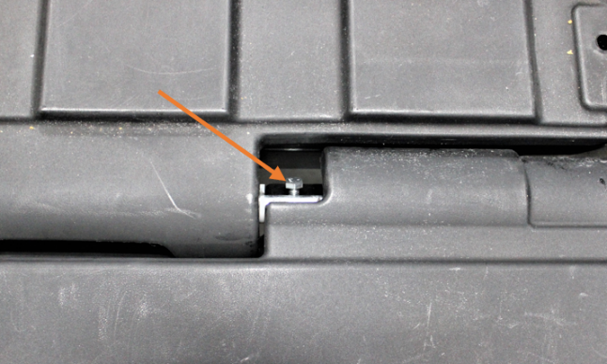
Figure 2: Tailgate Retaining Bolt

- Attach the left and right mounting brackets to the corresponding locations on the bumper using the hex bolts and nylock nuts. Figure 4 shows the proper direction.
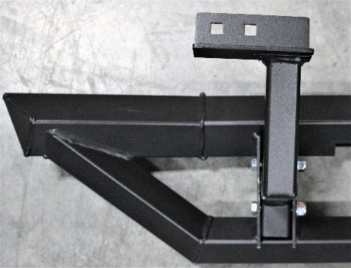
Figure 3: Mounting Bracket Direction
- Locate the rear bumper mounting holes on the rear frame member just under the tailgate hinge.
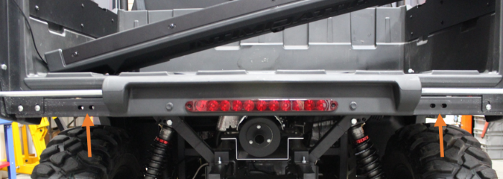
Figure 4: Bumper Mounting Holes
- Position the mounting brackets against the mounting holes and use the slide brackets, carriage bolts, and nylock nuts to secure the bumper to the frame.
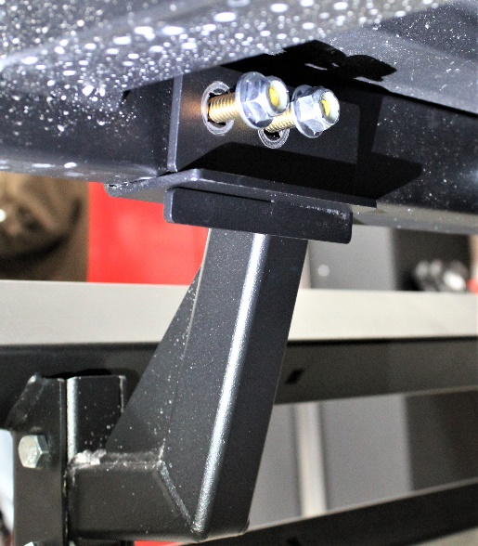
Figure 5: Mounting Bracket Position
- Fasten the accent plate to the inside of the logo plate with 4 machine screws, nuts, and washers.
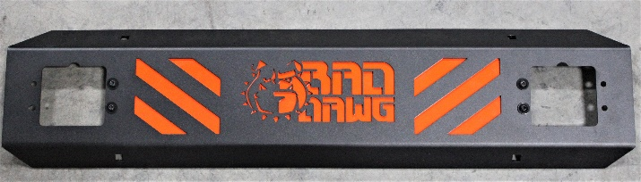
Figure 6: Logo Plate with Accent Plate
- Fasten the logo plate to the outside of the bumper using 4 carriage bolts and nylock nuts.
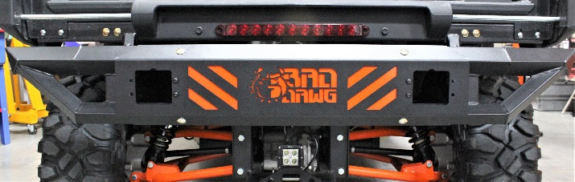
Figure 7: Logo Plate on Bumper
- If you have lights to install in the available spaces, do so before tightening the assembly, otherwise use the included metal plates to cover the light holes.

- Ensure that all hardware is tightened securely, and enjoy your ride!
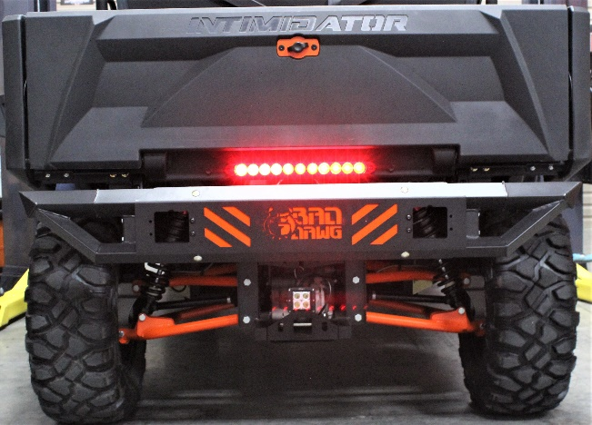
Figure 8: Bumper Installation Complete

Pod Light Installation

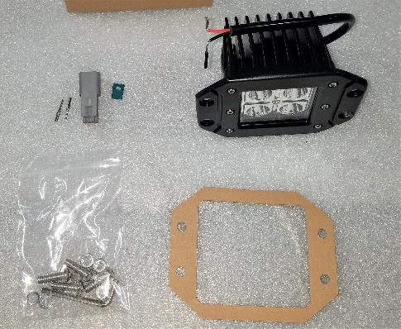
Figure 9: Pod Light Kit for One Light
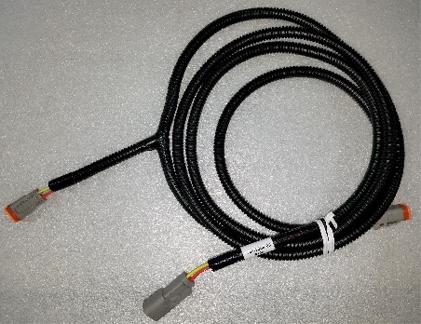
Figure 10: Pod Light Jumper
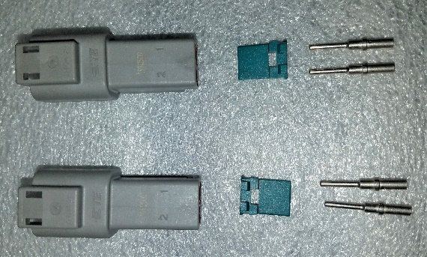
Figure 11: Pod Light Deutsch Connector Kits
- Attach a wiring pin to the stripped end of the red and black wires attached to the Pod light. Crimp the barrels to secure the pins onto the wires.
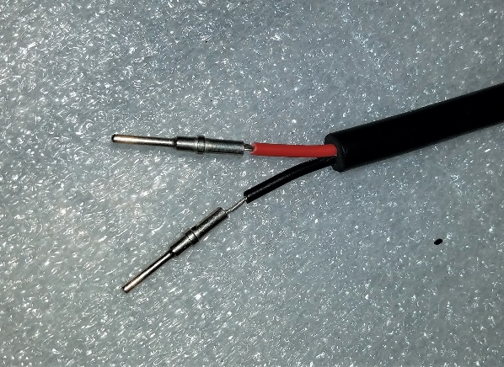
Figure 12: Pins Connected to Wires
- Insert the pins into the included Deutsch connectors through the holes in the backside. The red wire into hole 1, and the black wire into hole 2.
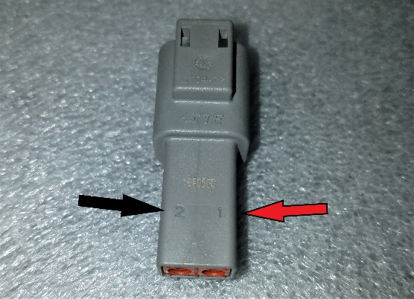
Figure 13: Deutsch Connector Numbers
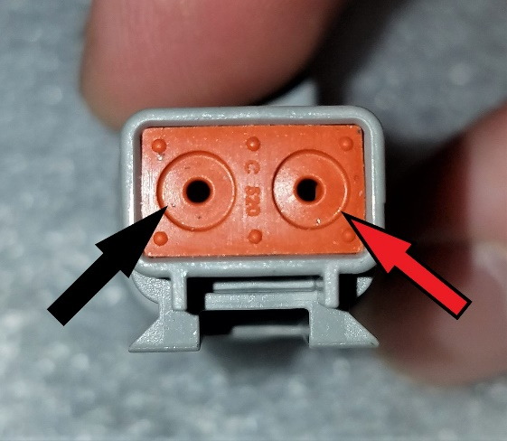
Figure 14: Deutsch Connector Holes

- Secure the wire pins into the Deutsch connector using the included blue pin holder wedge, which will snap into place when correctly inserted.
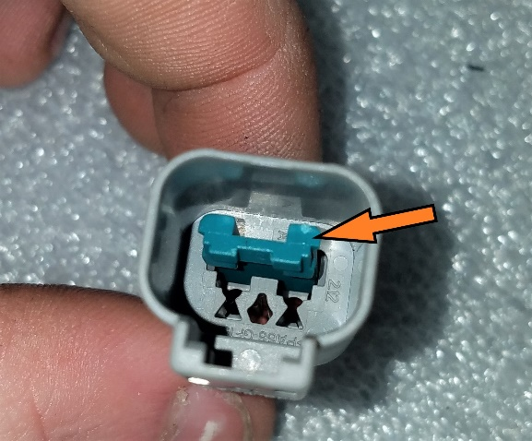
Figure 15: Pin Holder Wedge

- Mount the pod lights in the square mounting holes inside the tube bumper using the included hardware.

- Locate the harness Deutsch connector on the machine directly above and to the driver’s side of the rear differential.
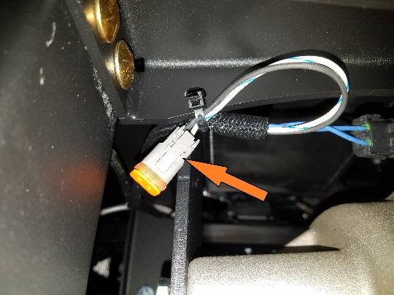
Figure 16: Harness Deutsch Connector
- Attach the individual end of the pod light jumper to the Deutsch connector, and route the jumper well away from the exhaust along the bed support struts.
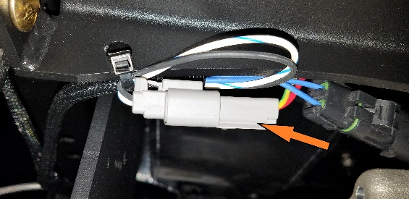
Figure 17: Jumper Connected to Harness
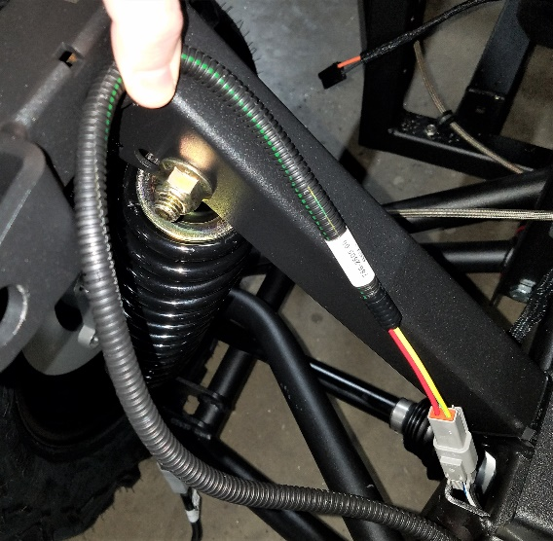
Figure 18: Example Routing
- Connect each pod light to the connectors on the jumper making sure to do so in a way that keeps the jumper well away from the exhaust and from any components that may pinch the jumper.

- Secure the jumper using cable ties.

