Safety:
- Ensure that the UTV is safely parked on level ground with the ignition off.
- Wear all appropriate PPE for the following procedures.

Note:
- Leave all hardware loose until the entire assembly is in its final position.

Assembly Components:
Ensure that you have all of these components before beginning the installation.

1 x Bumper
2 x Lower Mounting Brackets (left and right)
2 x Upper Mounting Brackets (left and right)
1 x Aluminum Accent Plate
1 x Hardware Kit

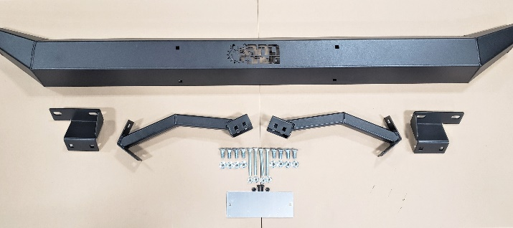
Figure 1: Kit Contents
Installation:

- Attach the aluminum accent plate to the inside of the bumper using the 2 small machine screws and nuts.
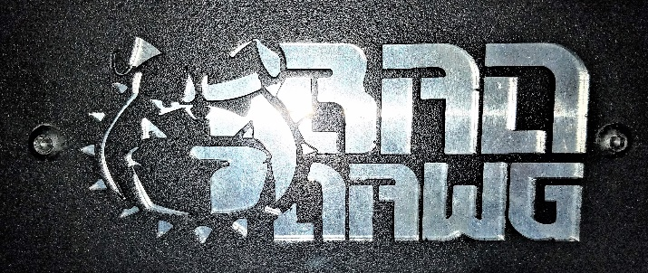
Figure 2: Accent Plate Front

- Attach the left and right lower mounting brackets to the bumper using 4 short carriage bolts and nuts.
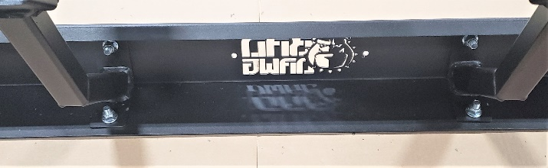
Figure 3: Upper Brackets to Bumper
- Remove the factory bolts below the tailgate to allow for future installation of the upper mounting brackets. Shown in Figure 4.
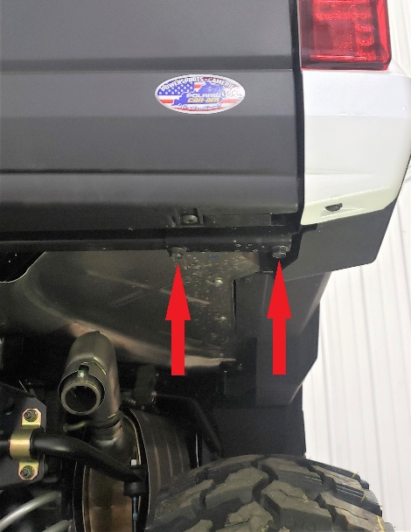
Figure 4: Factory Bolts for Removal
- Position the lower mounting brackets with the mounting location shown in Figure 5, and secure them using 4 long carriage bolts and nuts.
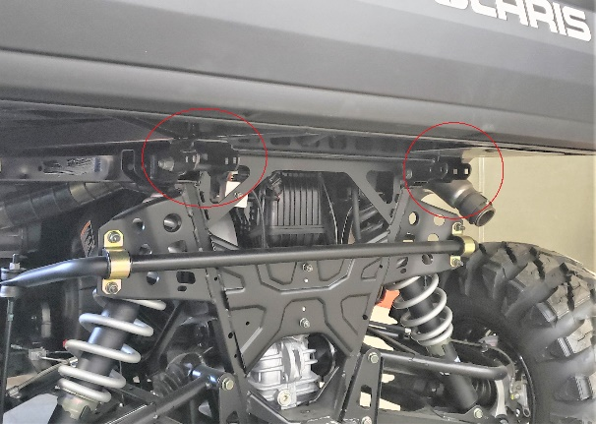
Figure 5: Lower Bracket Mounting Location
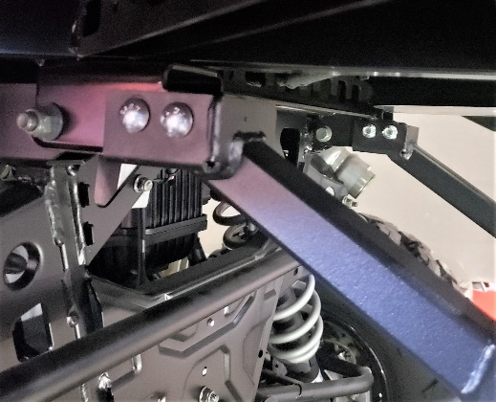
Figure 6: Lower Brackets to Machine
- Align the left and right upper mounting brackets with the mounting location on the bumper and machine and secure using short bolts.
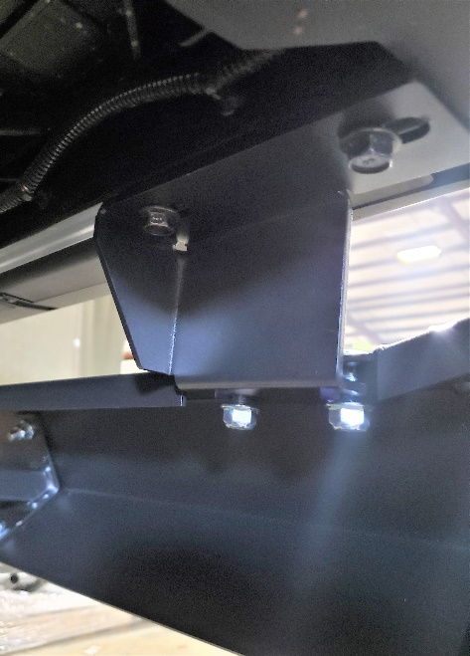
Figure 7: Upper Bracket to Machine and Bumper

- Tighten all hardware securely, and enjoy your ride!
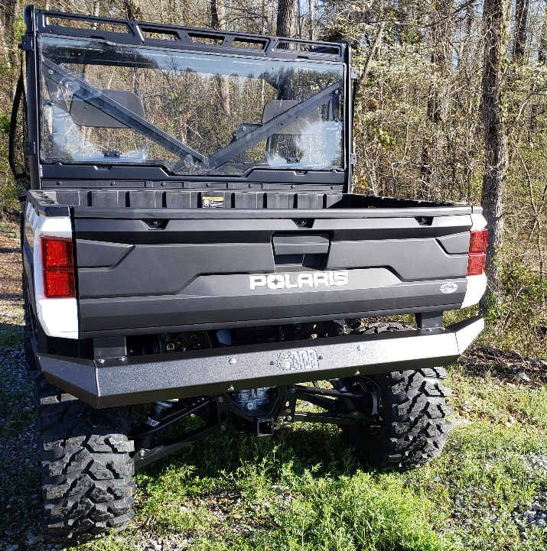
Figure 8: Install Complete

