Safety:
- Ensure that the UTV is safely parked on level ground with the ignition off.
- Wear all appropriate PPE for the following procedures.

Note:
- Leave all hardware loose until the entire assembly is in its final position.

Assembly Components:
Ensure that you have all of these components before beginning the installation.

1 x Rear Bumper
1 x Hardware Kit

Installation:

- Remove the two factory bolts from the outside of the bottom of the cargo bed.

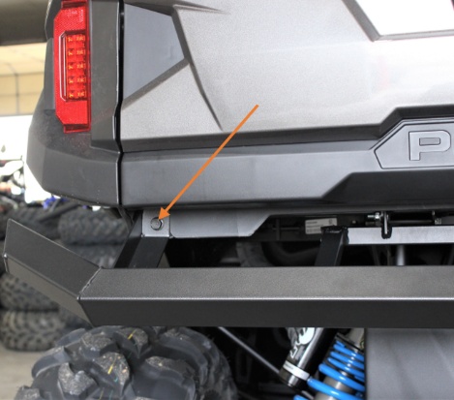
Figure 1: Exterior Mounting Point
- Align the bumper with the mounting locations on the bed and frame under the center of the bed.

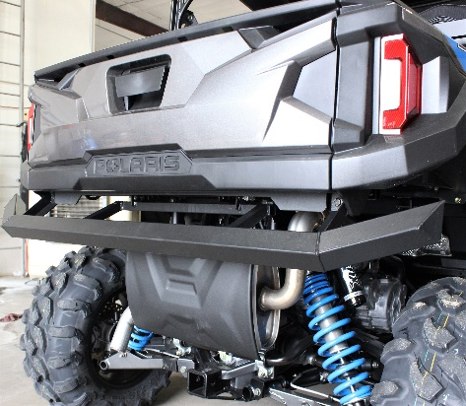
Figure 2: Positioned Bumper

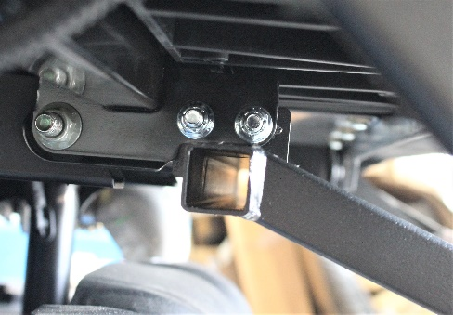
Figure 3: Mounting Location Under the Bed
- Utilize the factory bolts and supplied bolts and nuts to fasten the bumper to the machine.
- Tighten all hardware securely.

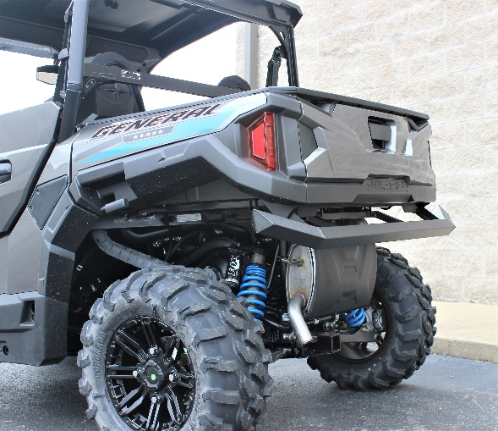
Figure 4: Install Complete

