Safety:
- Ensure that the UTV is safely parked on level ground with the ignition off.
- Wear all appropriate PPE for the following procedures.

Note:
- Leave all hardware loose until the entire assembly is in its final position.

Assembly Components:
Ensure that you have all of these components before beginning the installation.

1 x Metal Roof Panel
12 x Roll Cage Clamps
1 x Large Accent Plate
2 x Side Panels
2 x Small Accent Plates
1 x Hardware Kit

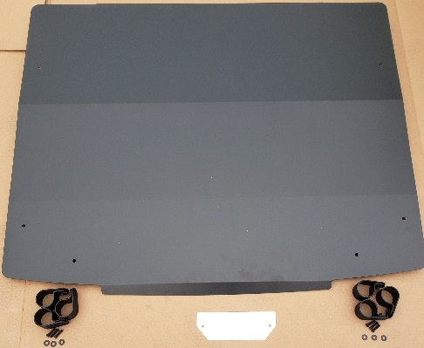
Figure 1: Kit Contents 1
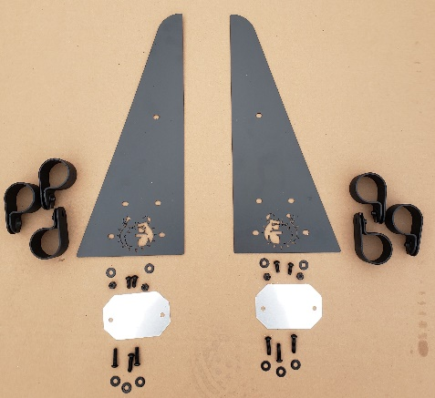
Figure 2: Kit Contents 2

Installation:

- Attach 6 of the roll cage clamps to the upper part of the machine’s roll cage as shown in Figure 3.
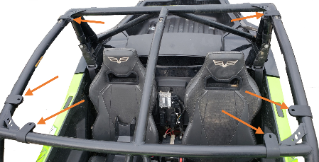
Figure 3: Roof Clamp Locations
- Fasten the large accent plate to the inside of the Bad Dawg logo using the included machine screws, nuts, and washers.
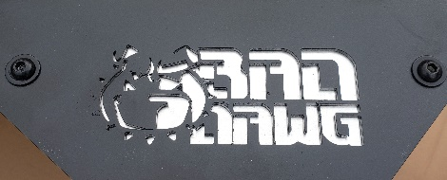
Figure 4: Roof Logo
- Position the roof on top of the machine in line with the roll cage and roll cage clamps. Secure the roof to the clamps using the included machine screws and washers.

- Attach 3 roll cage clamps to the roll cage on either side of the machine.
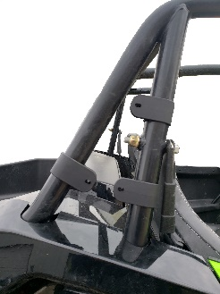
Figure 5: Side Panel Clamps Passenger Side
- Fasten a small accent plate to the inside of both side panels using the included machine screws and nuts.
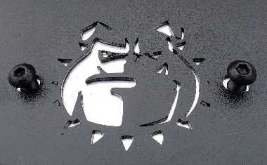
Figure 6: Side Panel Logo
- Align each side panel with its respective clamps and secure it using the included machine screws, nuts, and washers.
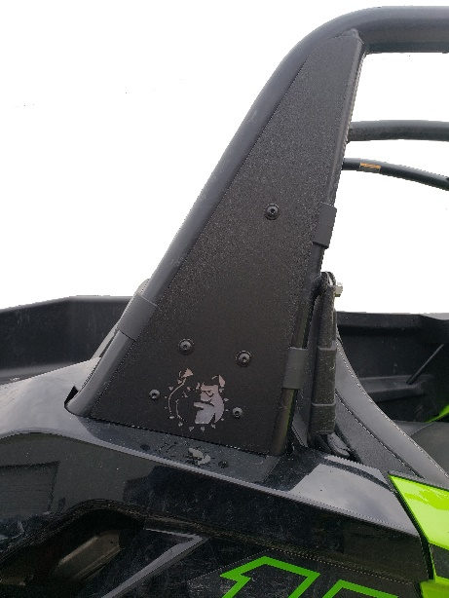
Figure 7: Mounted Side Panel
- Ensure that all hardware is tightened securely, and enjoy your ride!

