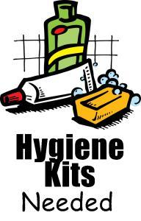
MHK is accepting Hurricane Hygiene Kits!!
In a large zip lock bag please include these 10 small, but not travel size, items if possible:
-Baby Wipes
-Hand Sanitizer
-Soap
-Deodorant
-Lotion
-Toothbrush
-Toothpaste
-Shampoo
-Conditioner
-Comb
*Please consider helping out…Your Kindness & Generosity is much appreciated.
Monetary Donations will also be accepted in our school office as well from now until Friday, September 22nd.
Your contributions will go directly to the Convoy of Hope to assist those families in need to our south…

