It is recommended that bolts remain “hand tight” until all bolts are installed.
Package includes:
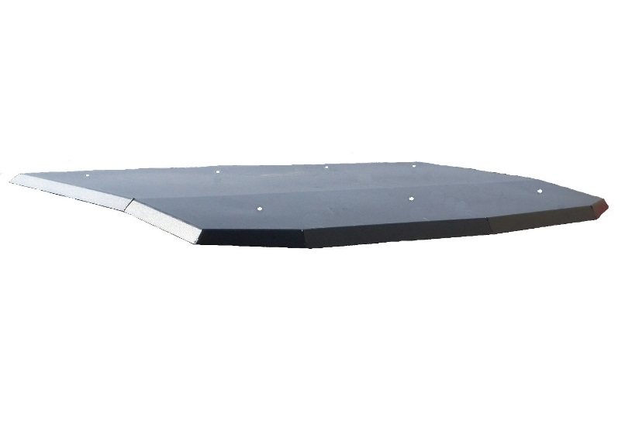  Roof Panel | 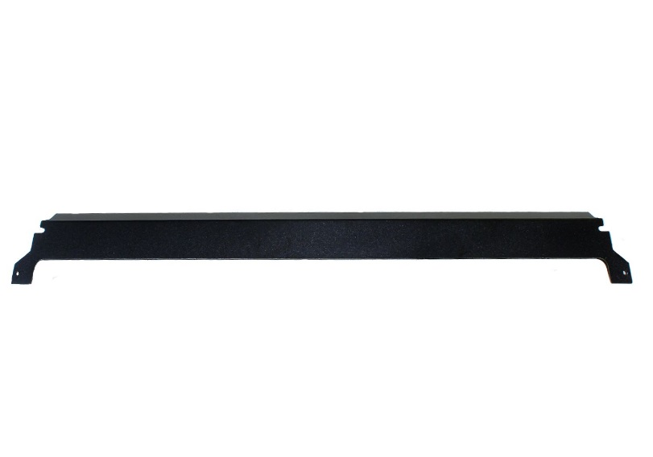  Rear Dust Panel
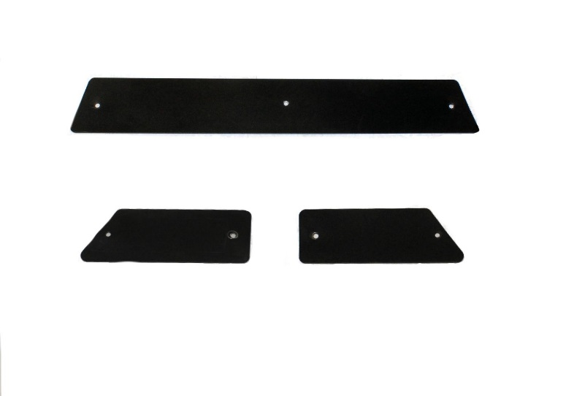  Dust Covers | 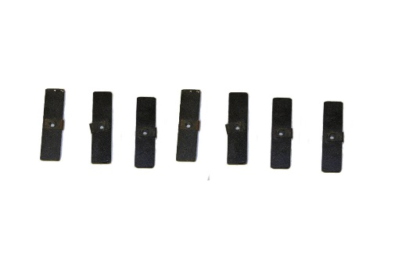  Dust Cover Clips
- 16- ¼-20 x ¾” button head (black)
- 16- ¼” flat washer (black)
- 9- ¼´ flanged nylock nut (zinc)

Bolt Kit

STEP 1  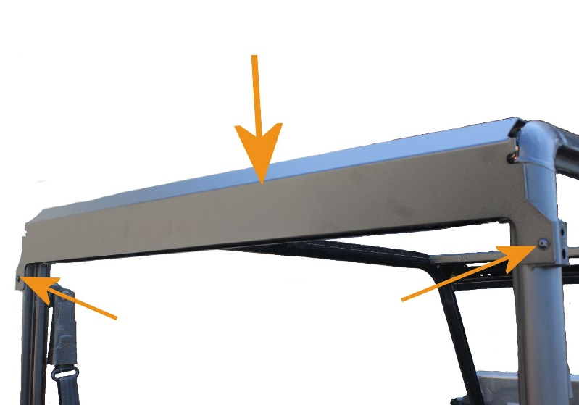 | - Mount the Rear Dust Panel using the provided bolts.
STEP 2  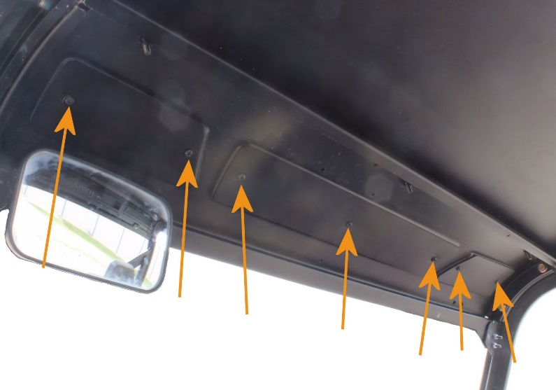 | - Set the individual Dust covers in place.  Note: this view is from the driver seat looking up.
STEP3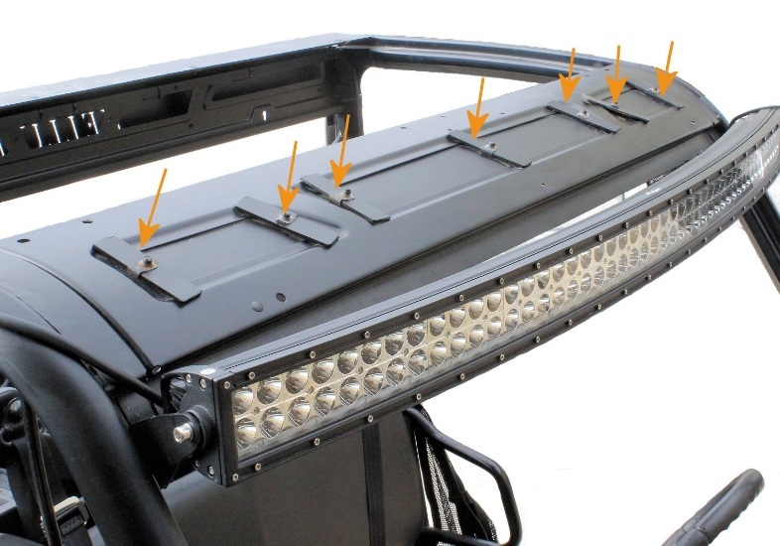 | - Secure each dust cover using the provided bolts with flat washers and the Dust Cover Clips.  Note: Light bar is not included in the package.

STEP 4  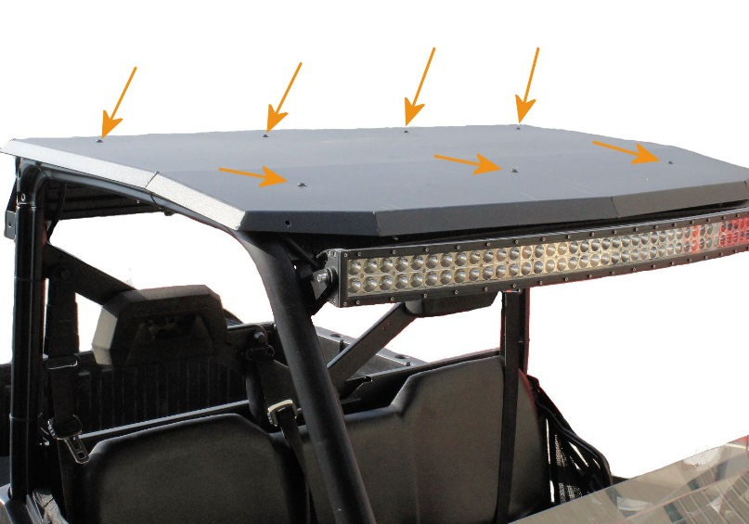 | - Secure the four rear bolts by aligning the holes with corresponding holes of the Rear Dust panel and inserting the provided bolts with flat washers.
STEP 5  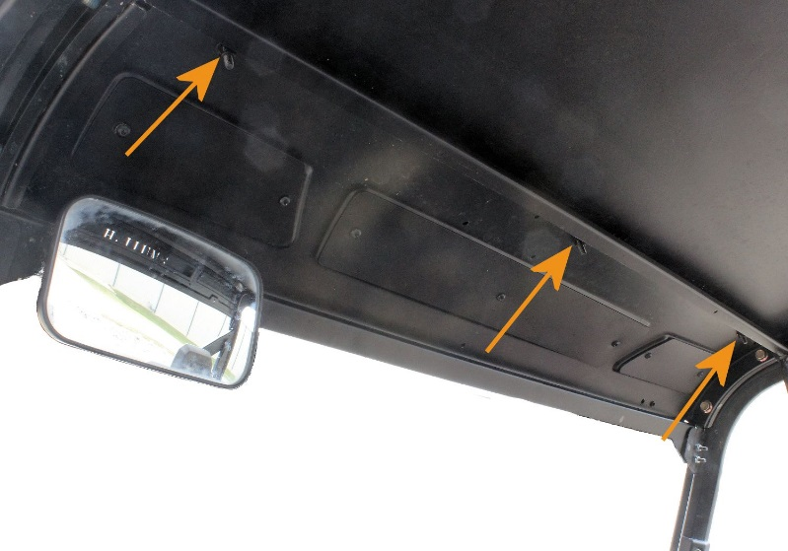 | - Secure the front by aligning the three holes in the Roof Panel with the corresponding holes in the machines front roll cage panel, indicated in this illustration
STEP 6 | - Tighten all bolts.

